KisanKraft – Post Budget Coverage Jan 2020

INDEX

S. NO | Coverage | Post/Stories
1. | Outlook India | 1
2. | The Week | 1
3. | The Asian Age | 1
4. | BW Businessworld | 1
5. | National Duniya | 1
6. | Gurgaon Today | 1
7. | Virat Vaibhav | 1
8. | Vyapar | 1

Publication | Outlook India
Headline | Agri industry & experts give mixed bag of response on budget
Date | 01/02/2020
Link | https://www.outlookindia.com/newsscroll/agri-industry--experts-give-mixed-bag-of-response-on-budget/1723927

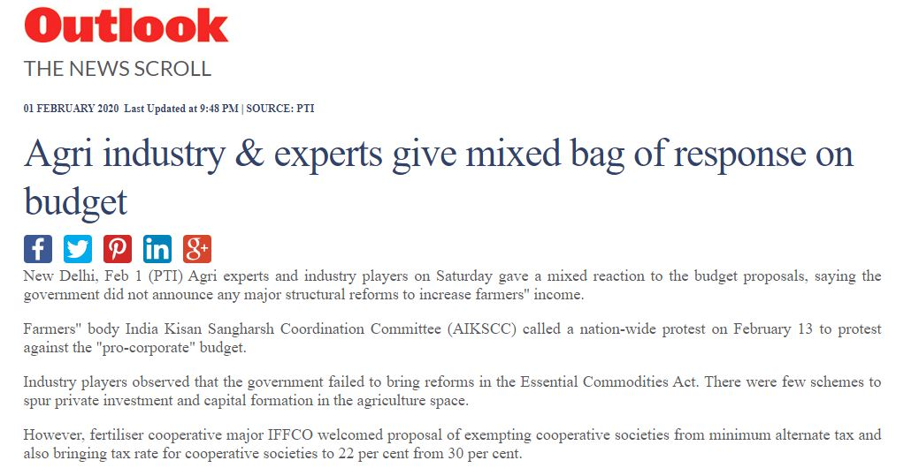

Publication | The Week
Headline | Budget 2020 aims to remove sluggishness of the rural economy with 16-point agenda
Date | 01/02/2020
Link | https://www.theweek.in/news/biz-tech/2020/02/01/budget-2020-aims-to-remove-sluggishness-of-the-rural-economy-with-16-point-agenda.html

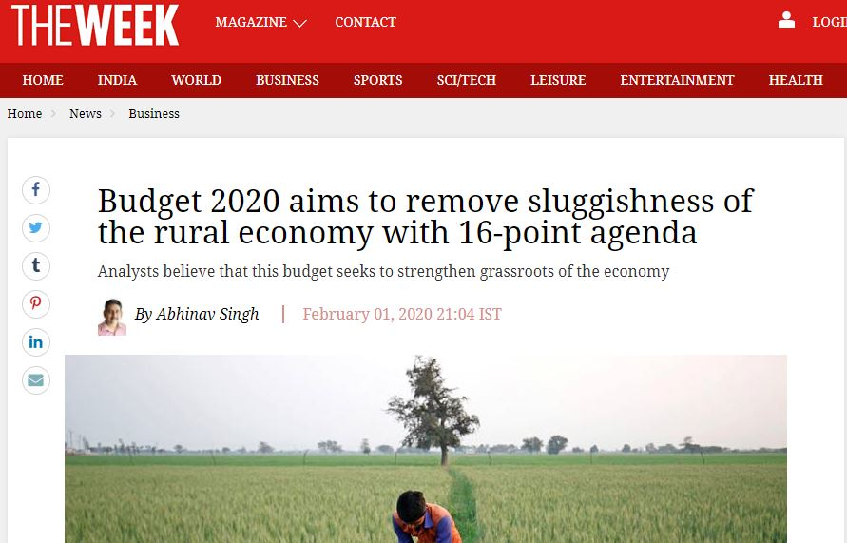
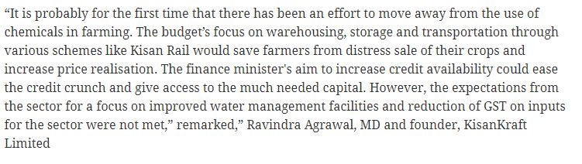

Publication | BW Businessworld
Headline | Union Budget 2020: Industry Reactions
Date | 01/02/2020
Link | http://www.businessworld.in/article/Union-Budget-2020-Industry-Reactions/01-02-2020-183236/

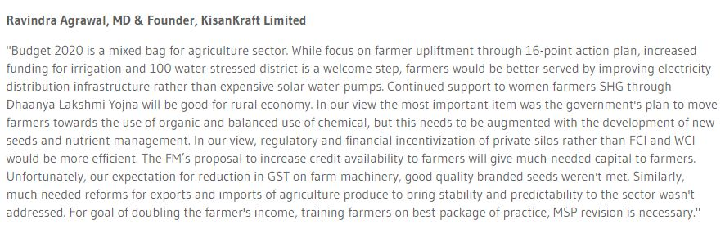

Publication | The Asian Age
Headline | Budget 2020 seeks to perk up agriculture sector
Date | 02/02/2020
Link | https://www.asianage.com/india/all-india/020220/budget-2020-seeks-to-perk-up-agriculture-sector.html

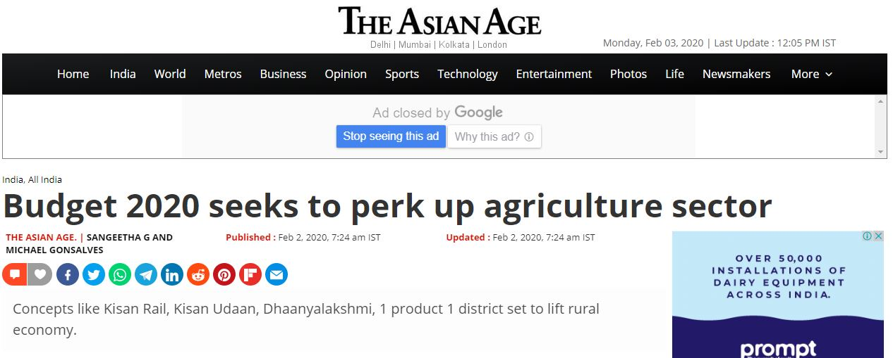
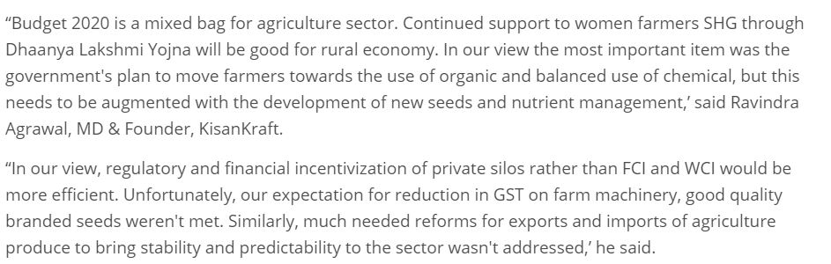

Publication | National Duniya
Headline | Regional
Date | 03/02/2020
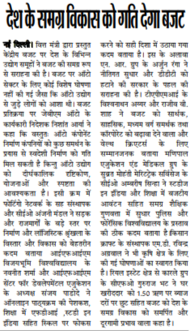

Publication | Gurgaon Today
Headline | Regional
Date | 03/02/2020

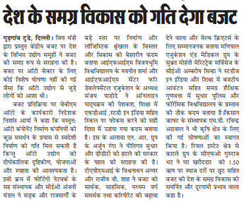

Publication | Virat Vaibhav
Headline | Regional
Date | 03/02/2020
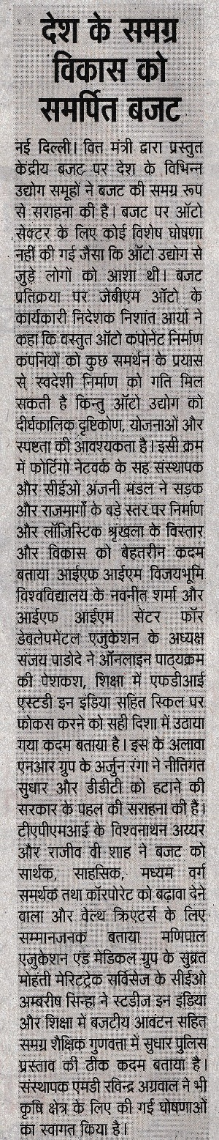

Publication | Vyapar
Headline | Regional
Date | 02/02/2020

