KisanKraft Coverage - Feb 2020
INDEX
S. NO | Coverage | Post/Stories
1. | The Economic Times | 1
2. | Sify.com | 1

Publication | The Economic Times
Headline | Increased Automation in Agriculture is a welcome change
Date | 14/02/2020
Link | https://epaper.timesgroup.com/Olive/ODN/TheEconomicTimes/?olv-cache-ver=20200130081009

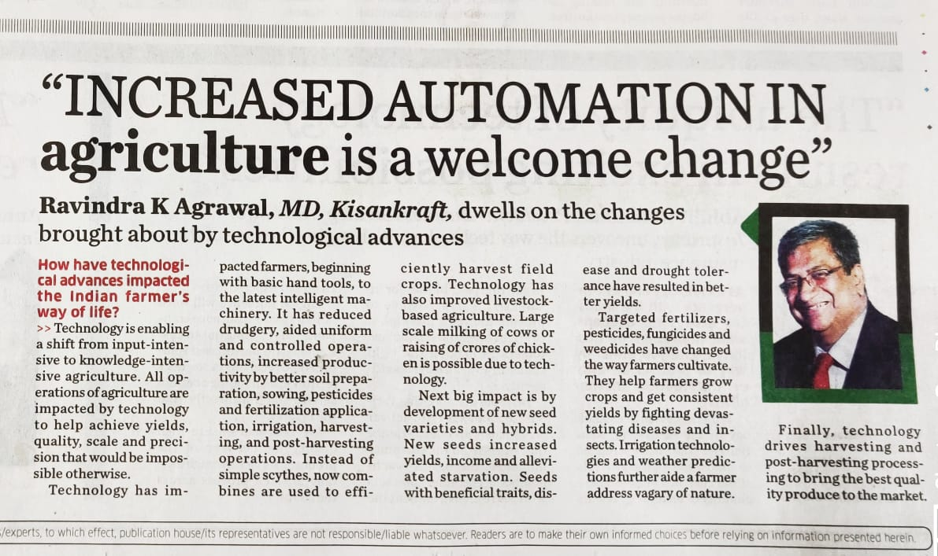

Publication | Sify.com
Headline | Nari-Shakti: Examining influence, roadblocks & potential of women in agriculture
Date | 24/02/2020
Link | https://www.sify.com/finance/nari-shakti-examining-influence-roadblocks--potential-of-women-in-agriculture-news-topnews-ucyqgQhbejehg.html

