QUARTERLY ACTIVITY REPORT

January – March , 2019

PRESENETED BY

Contents

Month | Activity
January | - Initiated interaction with Punya Nagari  - Initiated interaction with Entrepreneur  - Authored article with Malayalam Manorama
February | - Karnataka budget reaction quote  - Post-budget expectation vs. outcome  - Initiated interaction with Lokasatta  - Initiated interaction with ET Now
March | - Initiated interaction with Dainik Bhaskar  - Initiated interaction with Veer Arjun  - Initiated interaction with Rashtraya Sahara  - Initiated interaction with Vyapar  - Punjab Press Release

Activity Highlights

- Explored an opportunity for an email interaction with Punya Nagari on the issues faced in the agricultural sector and their solutions
Status: Coverage received and shared
- Authored article on Opportunities for Entrepreneurs in the Agricultural Sector
Status: Coverage received and shared in Entrepreneur
- Post-budget expectation vs. outcome
Status: Coverage received and shared
- Authored article on sustained food production in different climatic conditions
Status: Awaiting coverage in Malayalam Manorama
- Karnataka budget reaction quote
Status: Coverage received and shared
- Explored an opportunity with Loksatta on the Agricultural sector in India and how to improve it
Status: Awaiting coverage
- Explored an opportunity for a televised interview with ET Now on the Indian Agriculture outlook 2019
Status: Interaction postponed till the further notice
- Interaction opportunities with Punjab media on "The overuse of fertilizer"
Status: Coverage received and shared
- Explored an opportunity with Dainik Bhaskar on the current state of agriculture and farmers
Status: Coverage received and shared
- Article with Veer Arjun on the current state of agriculture and farmers
Status: Coverage received and shared
- Article with Rashtriya Sahara on the current state of agriculture and farmers
Status: Coverage received and shared
- Opportunity with Vyapar on the current state of agriculture and farmers
Status: Coverage received and shared

Coverage
Publication | Punya Nagari
Date | 31/12/18
Headline | Regional

Publication | Dainik Bhaskar
Date | 14/3/19
Headline | Regional

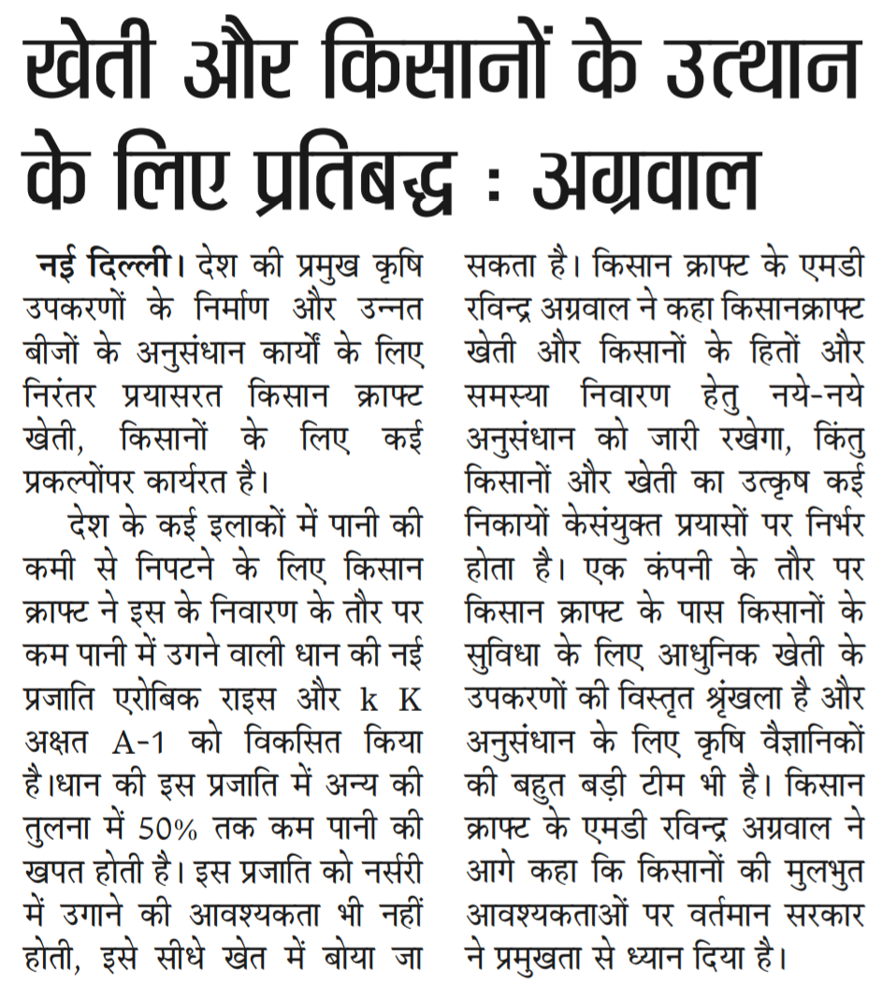

Publication | Corporate Citizen
Date | March issue
Headline | Budget 2019

PUBLICATION NAME: Entrepreneur
Headline | Opportunities for Entrepreneurs in the Agricultural Sector | Date | 25/2/2019
Link | https://www.entrepreneur.com/article/328865

Union Budget Coverage

PUBLICATION NAME: The Hindu
Headline | Telangana, Odisha pay more to support farmers | Date | 2/2/2019

PUBLICATION NAME: The Economic Times
Headline | Government's income support to farmers no match to Telangana & Odisha schemes: Experts | Date | 2/2/2019
Link | https://economictimes.indiatimes.com/news/economy/policy/governments-income-support-to-farmers-no-match-to-telangana-odisha-schemes-experts/articleshow/67796296.cms

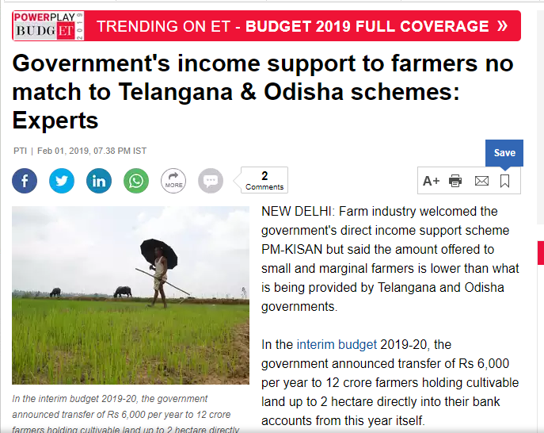

PUBLICATION NAME: The Times of India
Headline | Government's income support to farmers no match to Telangana & Odisha schemes: Experts | Date | 2/2/2019
Link | https://timesofindia.indiatimes.com/business/india-business/govts-income-support-to-farmers-no-match-to-telangana-odisha-schemes-experts/articleshow/67796049.cms

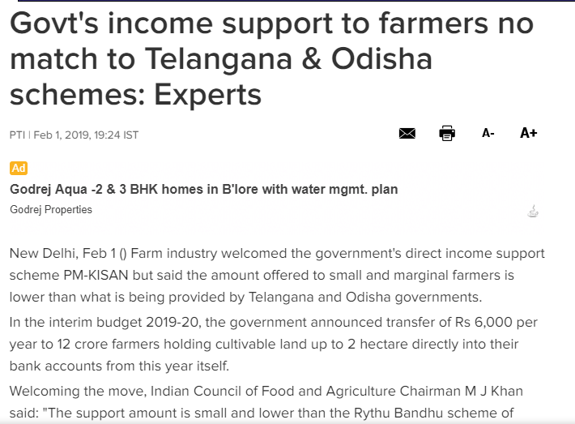

PUBLICATION NAME: The Hindu
Headline | Telangana, Odisha pay more to support farmers | Date | 2/2/2019
Link | https://www.thehindu.com/business/budget/telangana-and-odisha-pay-more/article26155315.ece

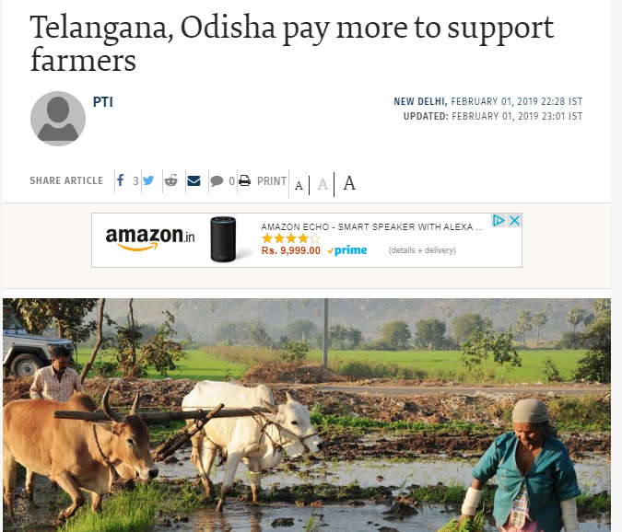

PUBLICATION NAME: CNBC TV18
Headline | Government's income support to farmers no match to Telangana & Odisha schemes: Experts | Date | 2/2/2019
Link | https://www.cnbctv18.com/agriculture/budget-2019-governments-income-support-to-farmers-no-match-to-telangana-and-odisha-schemes-say-experts-2162801.htm

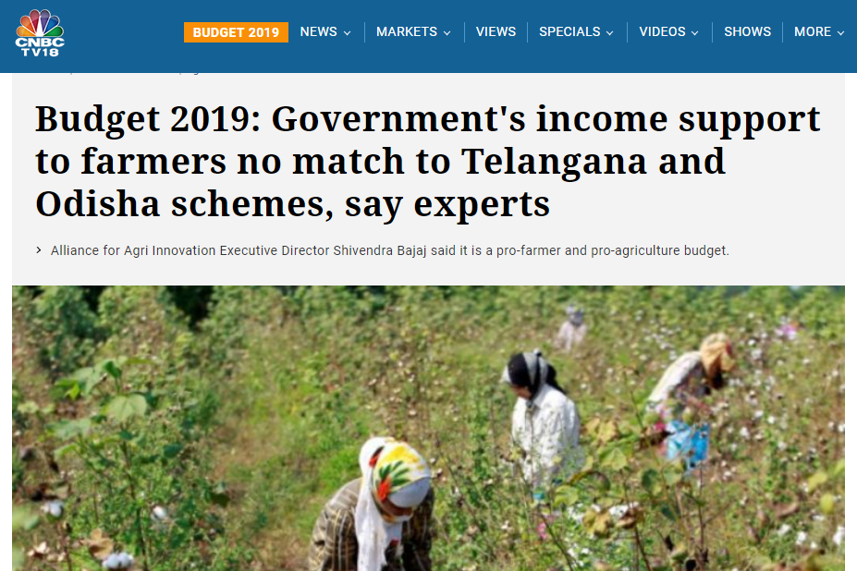

PUBLICATION NAME: Outlook India
Headline | Government's income support to farmers no match to Telangana & Odisha schemes: Experts | Date | 2/2/2019
Link | https://www.outlookindia.com/newsscroll/govts-income-support-to-farmers-no-match-to-telangana--odisha-schemes-experts/1470342

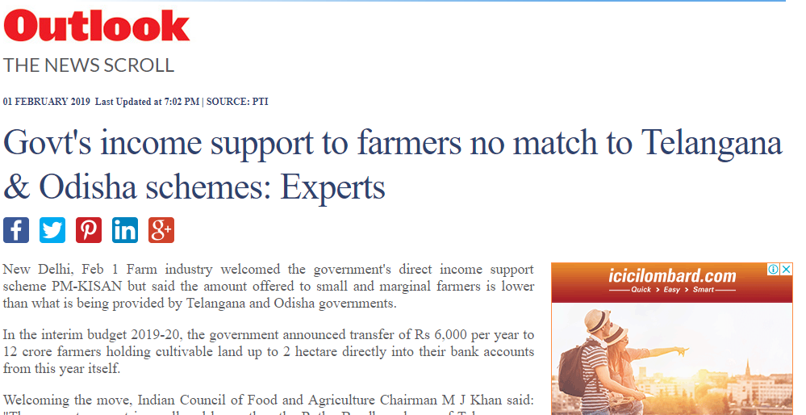

PUBLICATION NAME: Business Today
Headline | Government's income support to farmers no match to Telangana & Odisha schemes: Experts | Date | 2/2/2019
Link | https://www.businesstoday.in/pti-feed/govts-income-support-to-farmers-no-match-to-telangana-and-odisha-schemes-experts/story/316140.html

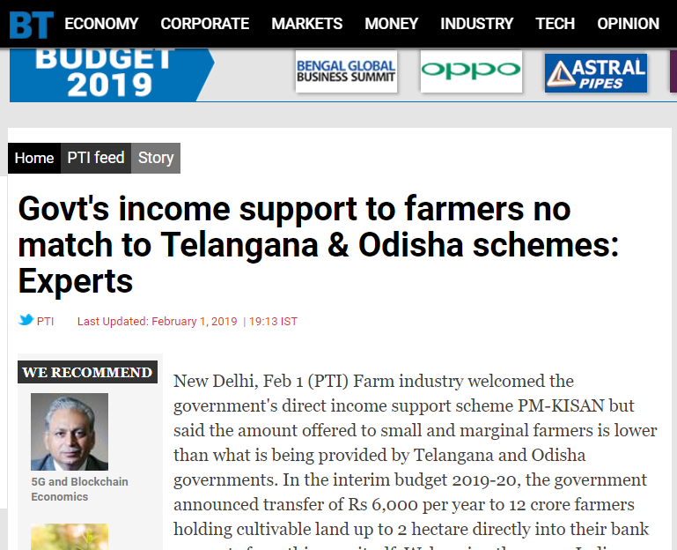

PUBLICATION NAME: Krishi Jagaran
Headline | Government's income support to farmers no match to Telangana & Odisha schemes: Experts | Date | 2/2/2019
Link | https://krishijagran.com/news/modi-s-income-support-to-farmers-is-no-match-to-odisha-telangana-s-agri-schemes-experts/

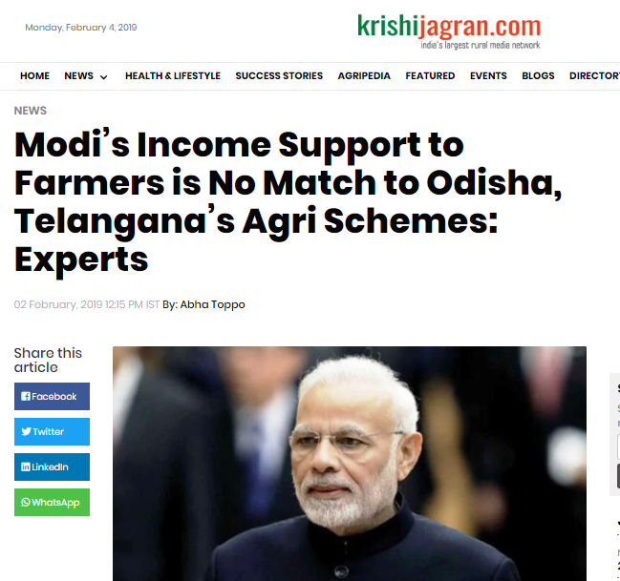

PUBLICATION NAME: Dainik Bhaskar
Headline | Regional | Date | 2/2/2019

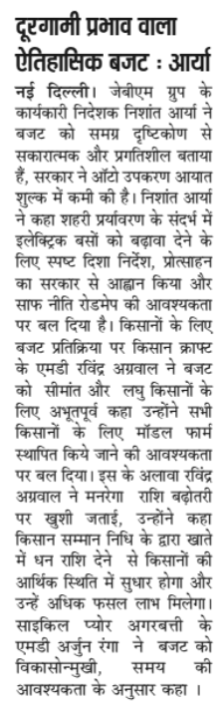

PUBLICATION NAME: National Duniya
Headline | Regional | Date | 2/2/2019

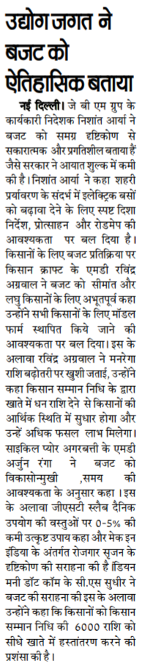

PUBLICATION NAME: Haryana Mail
Headline | Regional | Date | 2/2/2019

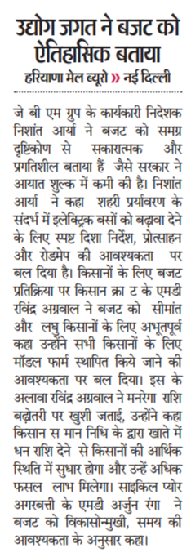

PUBLICATION NAME: Gurgaon Today
Headline | Regional | Date | 2/2/2019

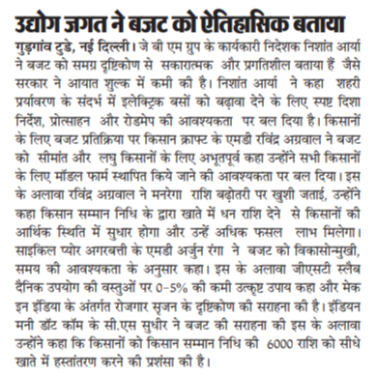

PUBLICATION NAME: Veer Arjun
Headline | Regional | Date | 2/2/2019

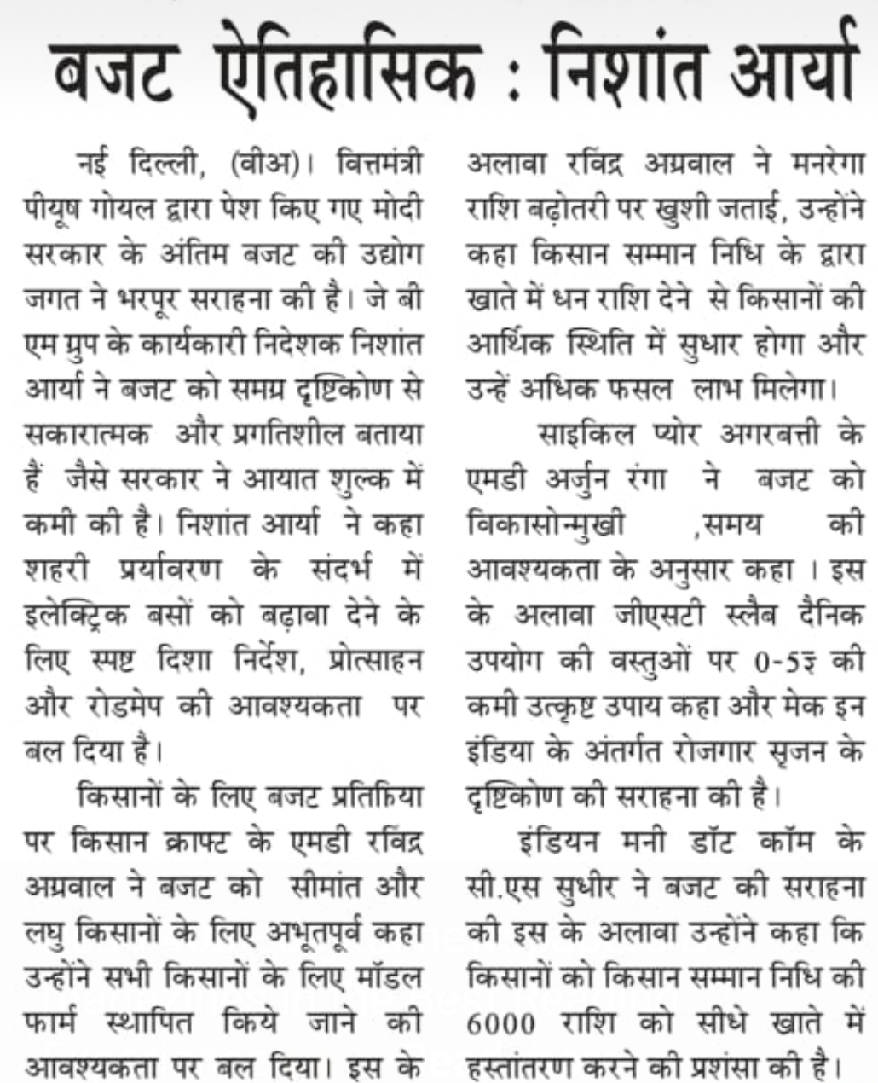

PUBLICATION NAME: Amrit India
Headline | Regional | Date | 2/2/2019

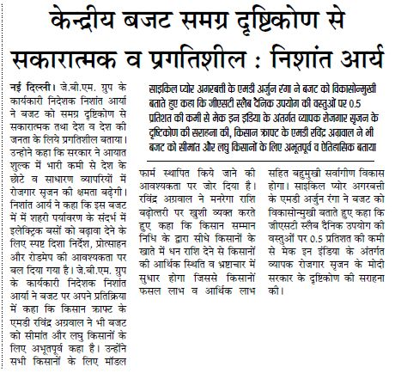

Karnataka Budget Coverage

PUBLICATION NAME: Udaiyavani
Headline | Regional | Date | 11/2/2019

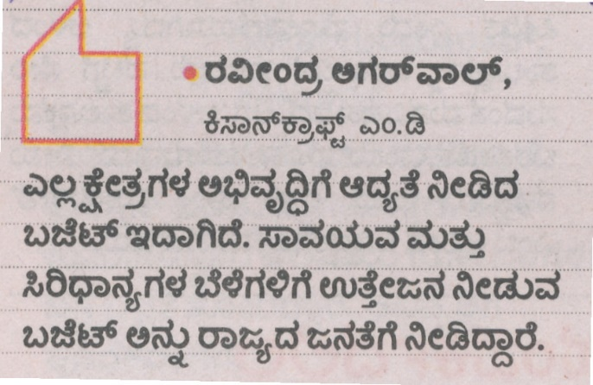

PUBLICATION NAME: Hosadigantha
Headline | Regional | Date | 11/2/2019

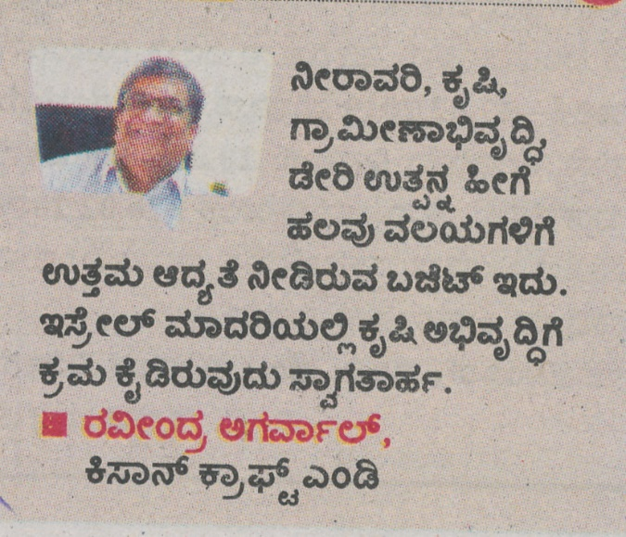

Publication | Rashtriya Sahara
Date | 21/3/19
Headline | Regional

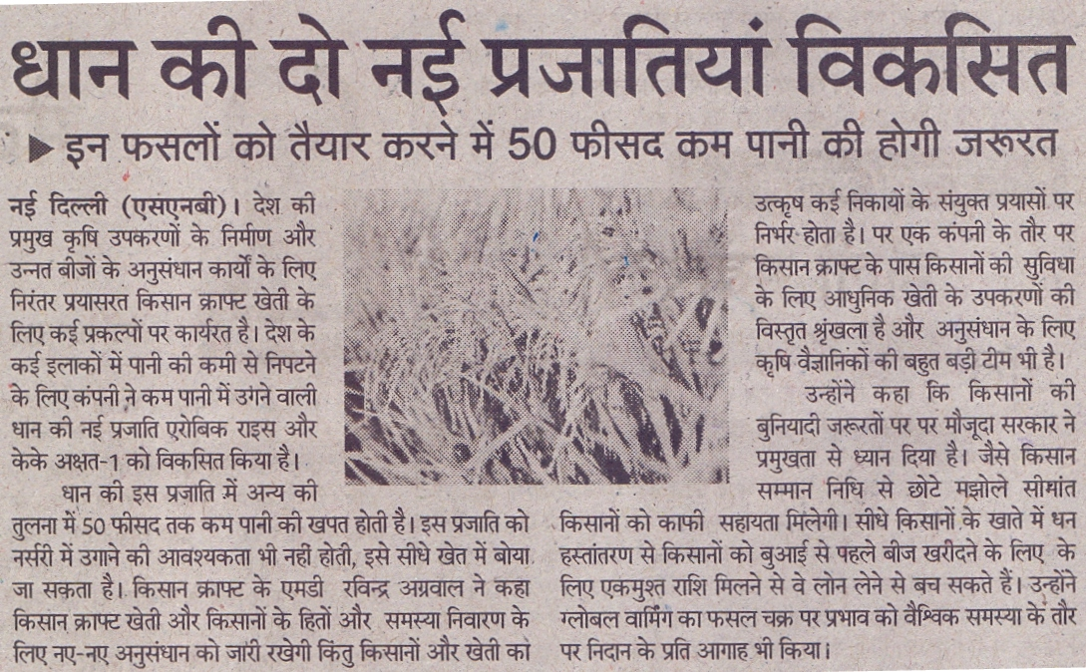

Publication | Veer Arjun
Date | 21/3/19
Headline | Regional

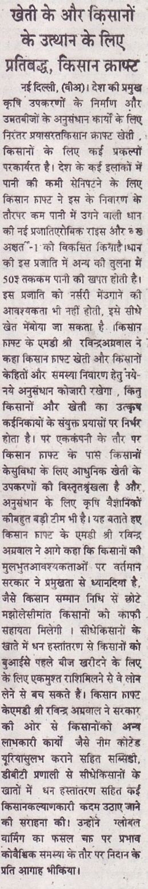

Publication | Vyapar
Date | 21/3/19
Headline | Regional

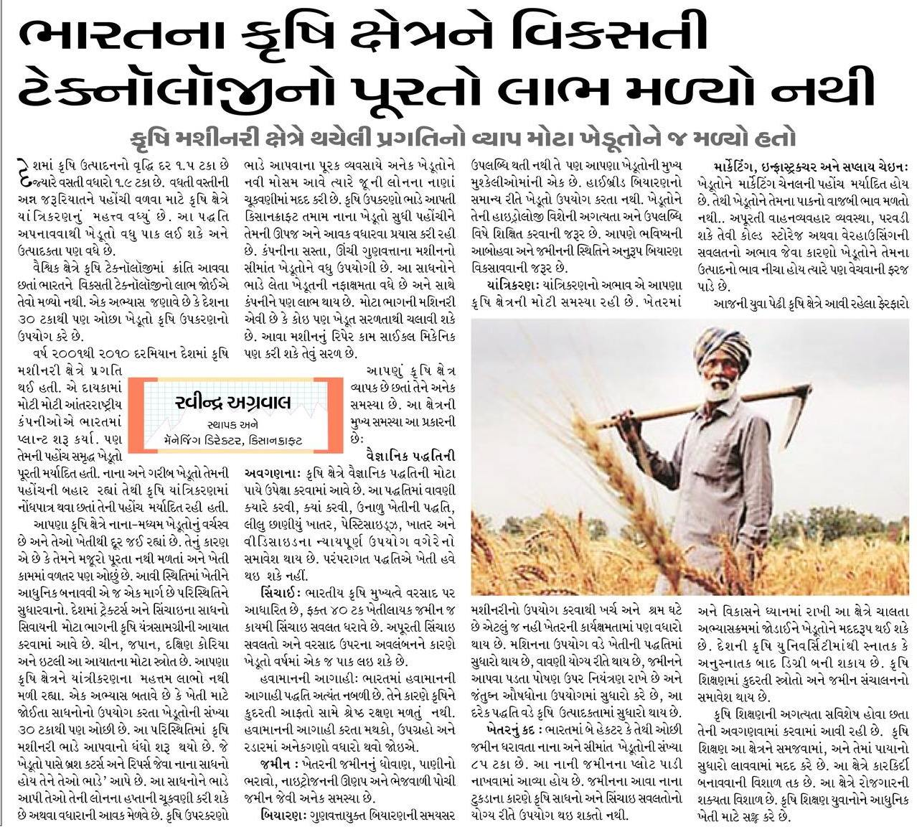

PUBLICATION NAME: Aapka Faisla
Headline | Regional | Date | 2/3/2019

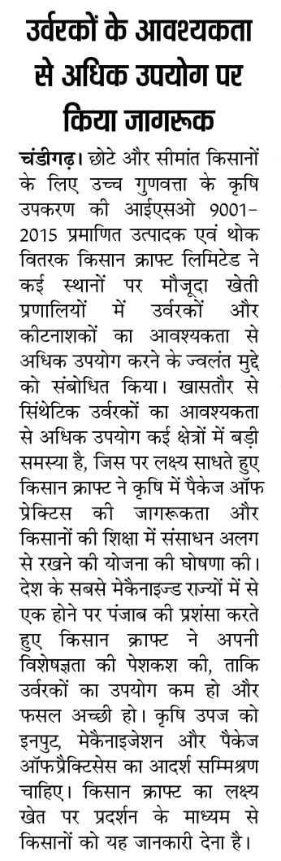

PUBLICATION NAME: WWN
Headline | Regional | Date | 1/3/2019
Link | http://www.worldwisdomnews.com/awareness-on-kisan-craft-provided/

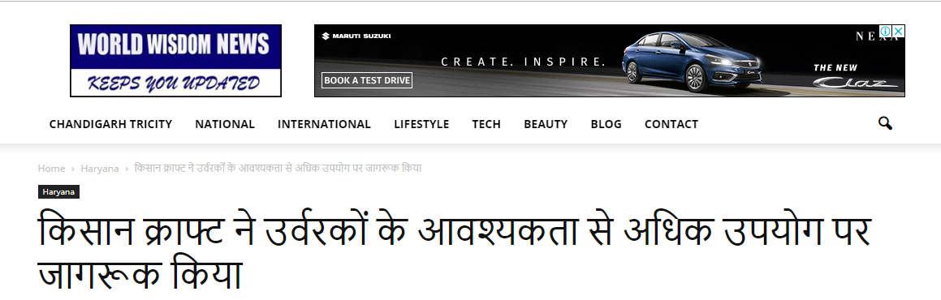

PUBLICATION NAME: Mangla Times
Headline | Regional | Date | 1/3/2019
Link | https://www.manglatimes.com/%E0%A4%95%E0%A4%BF%E0%A4%B8%E0%A4%BE%E0%A4%A8%E0%A4%95%E0%A5%8D%E0%A4%B0%E0%A4%BE%E0%A4%AB%E0%A5%8D%E0%A4%9F-%E0%A4%A8%E0%A5%87-%E0%A4%89%E0%A4%B0%E0%A5%8D%E0%A4%B5%E0%A4%B0%E0%A4%95%E0%A5%8B%E0%A4%82/

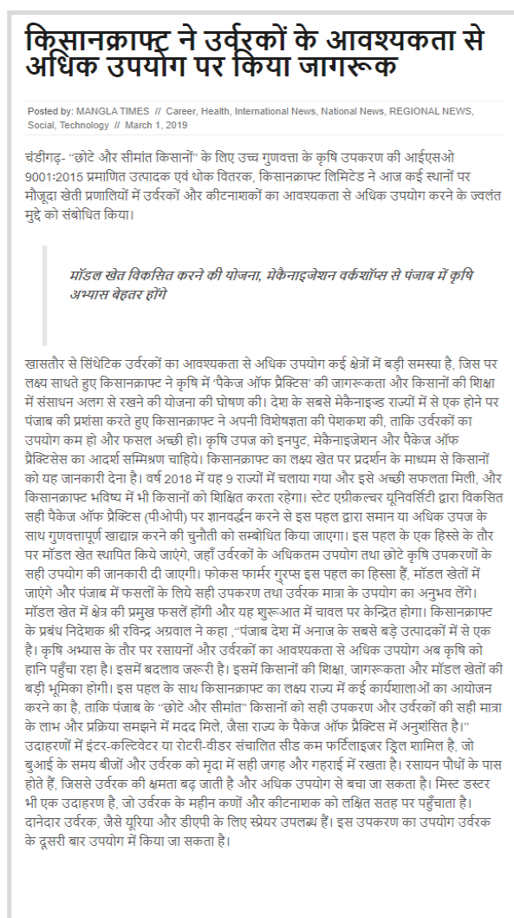

PUBLICATION NAME: Encouter News
Headline | Regional | Date | 2/3/2019
Link | http://encounterindia.in/kisan-kraft-made-aware-of-the-excess-use-of-fertilizers

