QUARTERLY REPORT

July-September 2019

Presented by

Month |  | Activity
July | - Aerobic rice demonstration Trichy  - Aerobic rice demonstration Jaipur  - Sakal Q&A Interaction for a story on ‘Making agriculture a profession and not a way of life’  - Pre budget quote  - Post budget quote  - Budget expectations – CNBC TV 18  - Spokesperson opportunity at Zee Business Dare To Dream conclave
August | - Farmer education drive in Nellore  - Pitched to Business Standard on "Water and Agriculture. A growing concern"
September | - Aerobic Rice demonstration in Kanakapura  - Pitched to The Hindu Business Line on "KisanKraft impacts farmer lives for the better"  - Pitch shared with Kannada Prabha on 'Importance of water management as the solution to Indian Agriculture woes'

Activity Highlights

- Aerobic rice demonstration in Trichy
Status: Coverage received and shared

- Aerobic rice demonstration in Jaipur
Status: Coverage received and shared
- Sakal Q&A Interaction for a story on ‘Making agriculture a profession and not a way of life’
Status: Coverage received and shared

- Post budget quote
Status: Coverage received and shared
- Pre budget quote
Status: Coverage received and shared
- Budget expectations – CNBC TV 18
Status: Coverage received and shared
- Spokesperson opportunity at Zee Business Dare To Dream conclave
Status: Speaking opportunity complete
- Farmer education drive in Nellore
Status: Coverage received and shared
- Aerobic Rice demonstration in Kanakapura
Status: Coverage received and shared
- Pitched to Business Standard on "Water and Agriculture. A growing concern"
Status: Journalist to confirm on date of interaction
- Pitch shared with Kannada Prabha on 'Importance of water management as the solution to Indian Agriculture woes'
Status: Interaction to be scheduled
- Pitched to The Hindu Business Line on "KisanKraft impacts farmer lives for the better"
Status: Journalist interested in doing an interview, to finalize on date of interaction

Budget Expectations – CNBC TV 18

Coverage

TV Channel | CNBC TV 18
Date | 03/07/2019

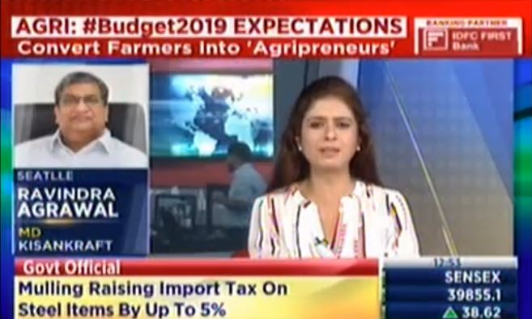

Aerobic rice Demonstration

Jaipur

Coverage

Publication | Daily News
Headline | Regional
Date | 03/07/2019

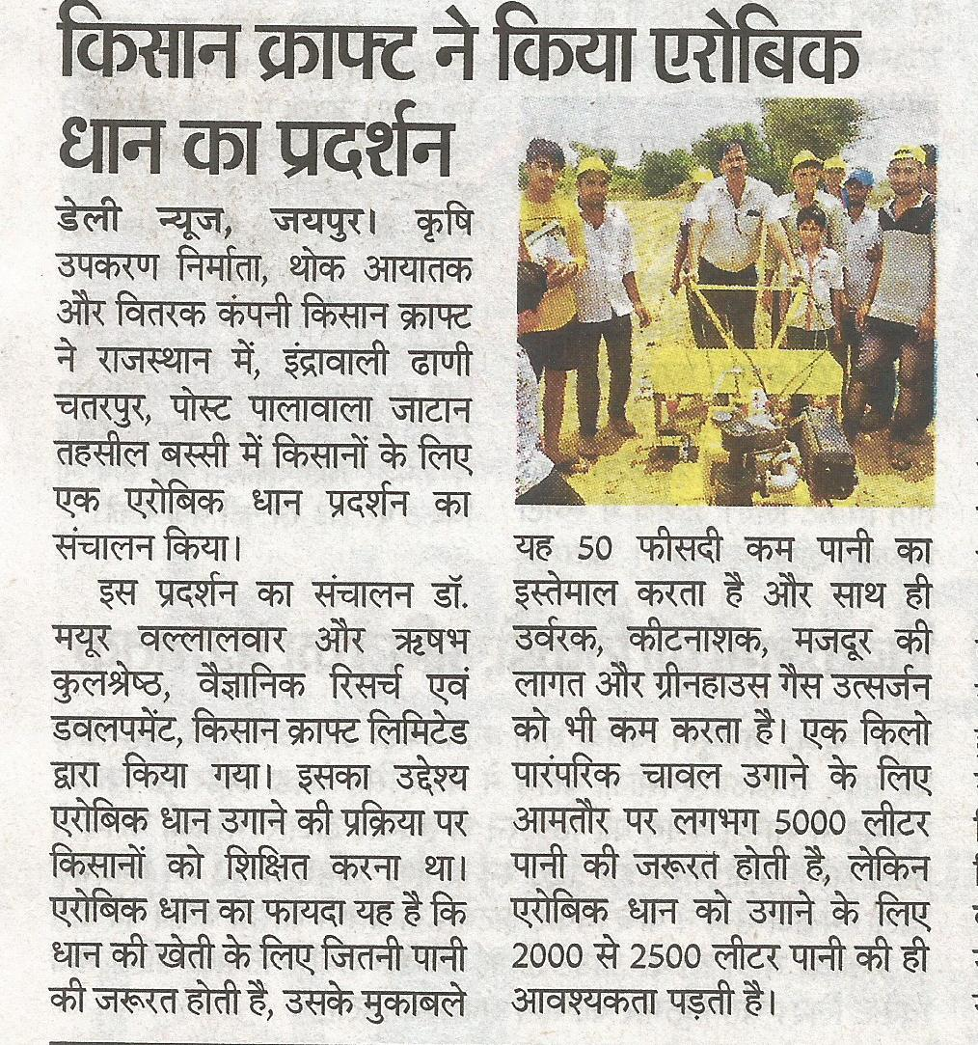

Publication | Dainik Bhaskar
Headline | Regional
Date | 03/07/2019
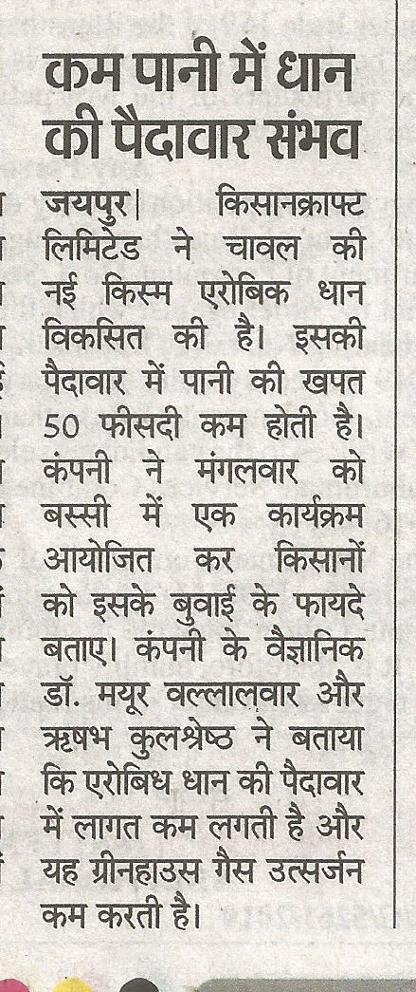

Publication | Dainik Navjyothi
Headline | Regional
Date | 03/07/2019

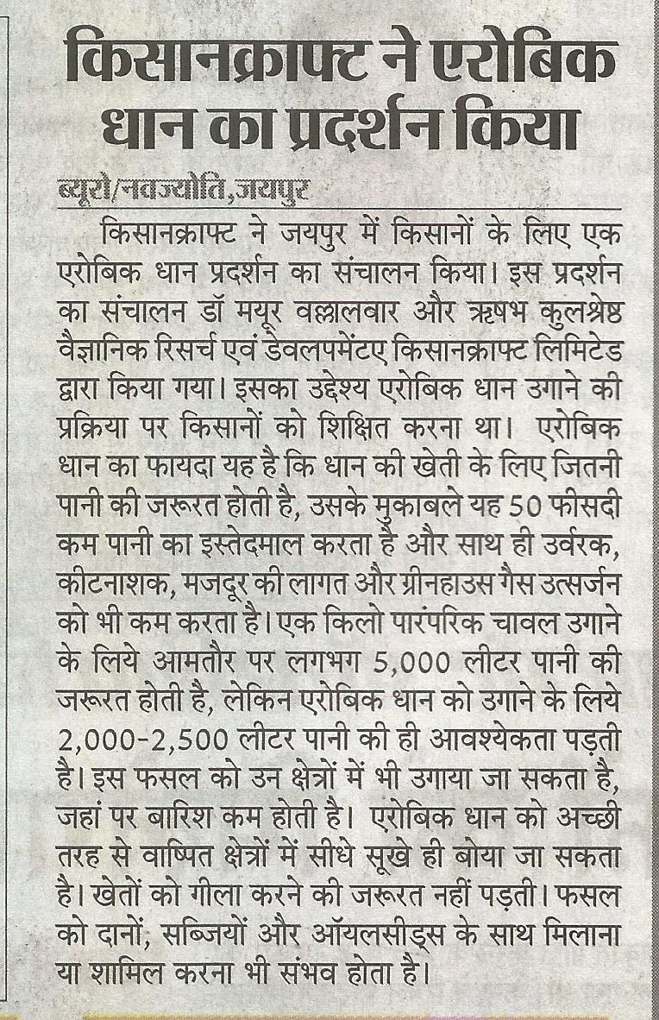

Publication | Morning News
Headline | Regional
Date | 03/07/2019

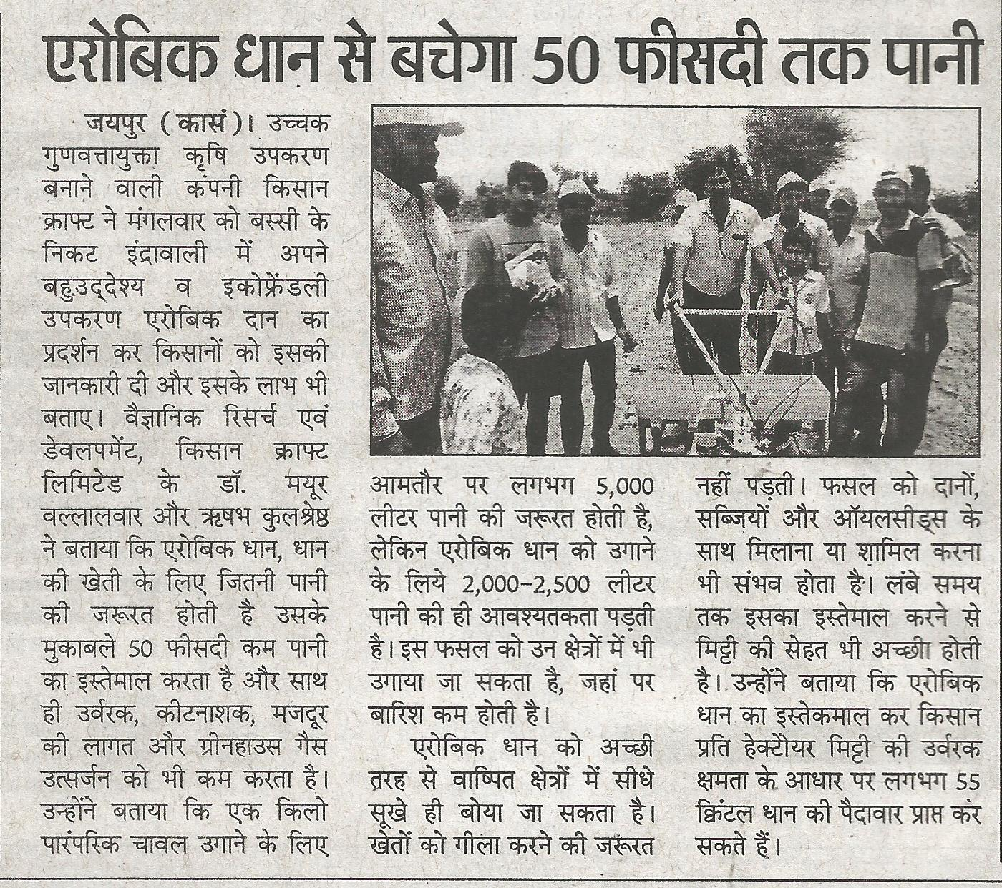

Publication | Hukumnama Samachar
Headline | Regional
Date | 03/07/2019

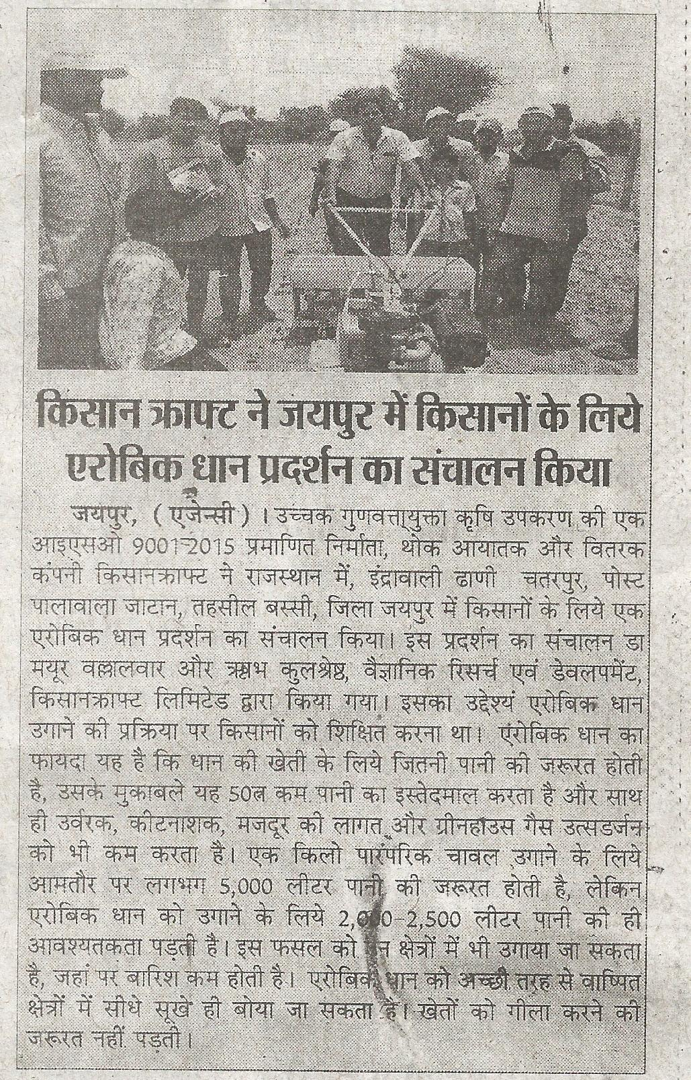

Publication | Samachar Jagat
Headline | Regional
Date | 03/07/2019

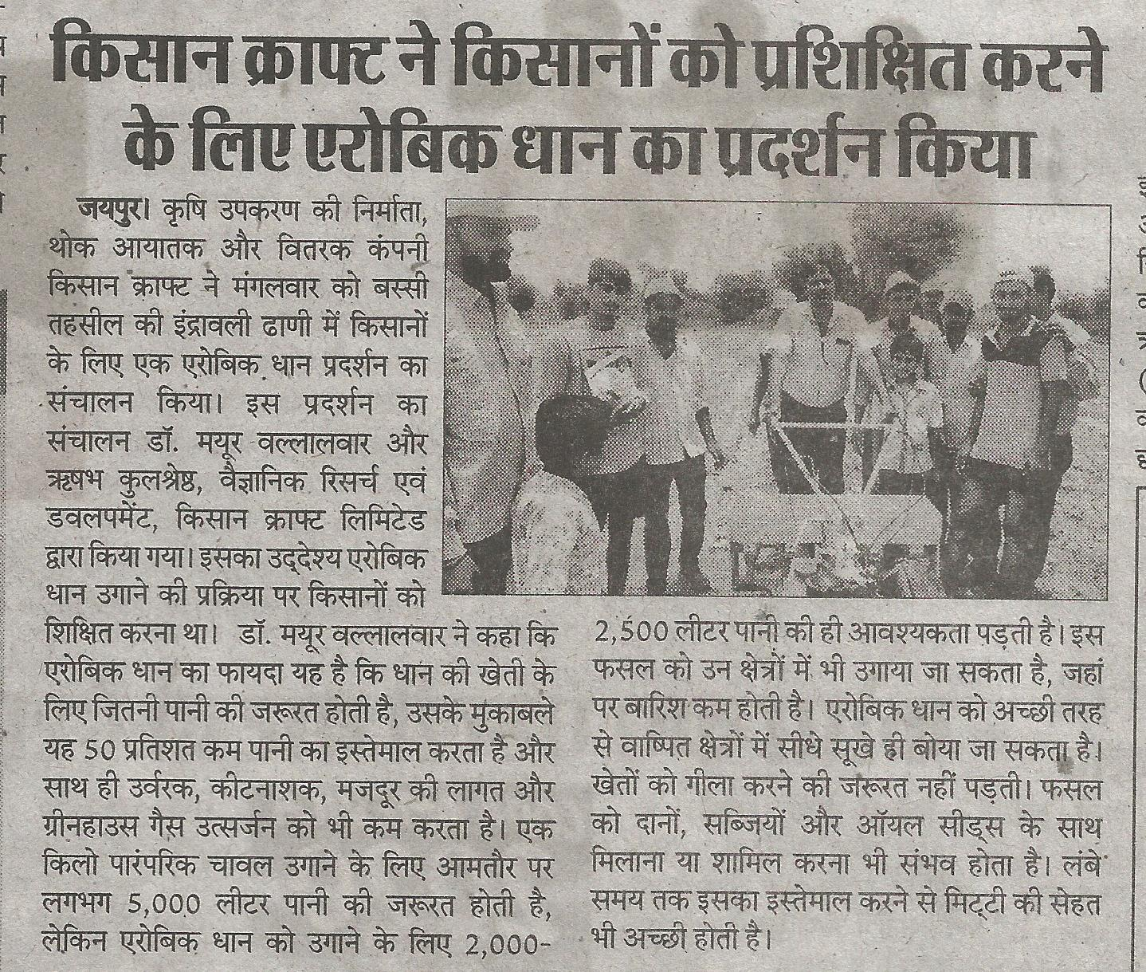

Publication | Pratah Kal
Headline | Regional
Date | 03/07/2019

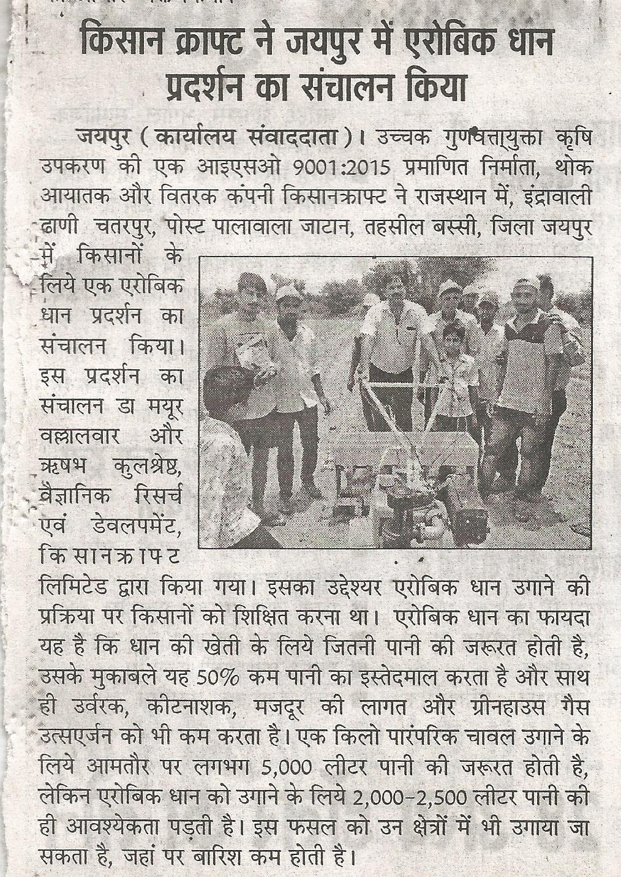

Publication | Dainik Bhor
Headline | Regional
Date | 03/07/2019

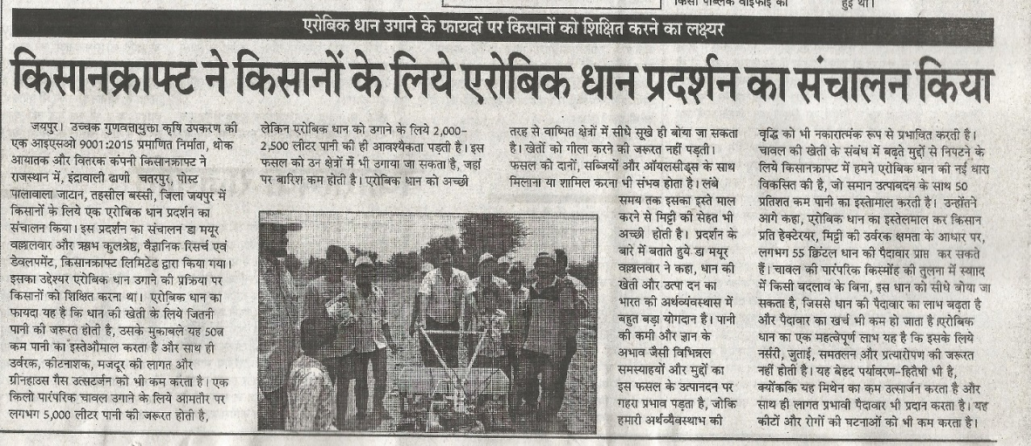

Publication | Jagruk Times
Headline | Regional
Date | 03/07/2019

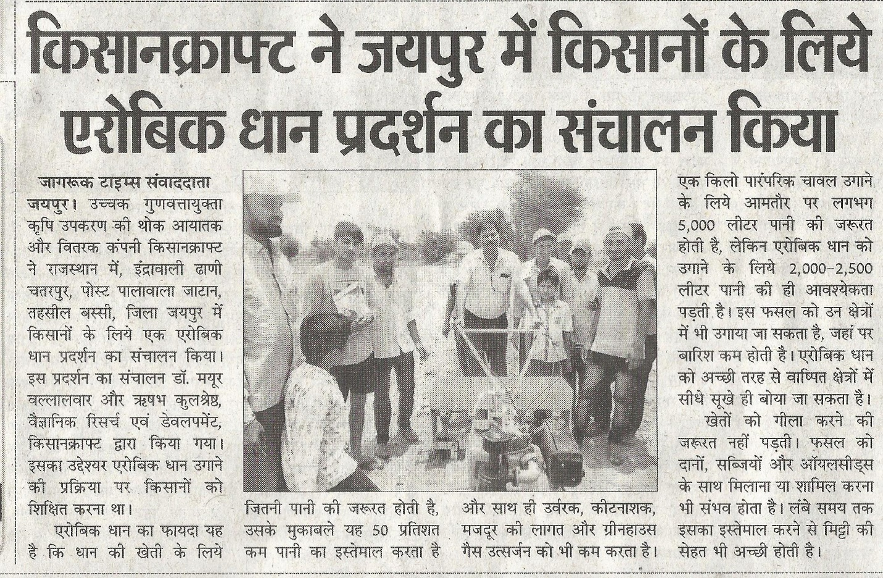

Publication | Evening Post
Headline | Regional
Date | 03/07/2019

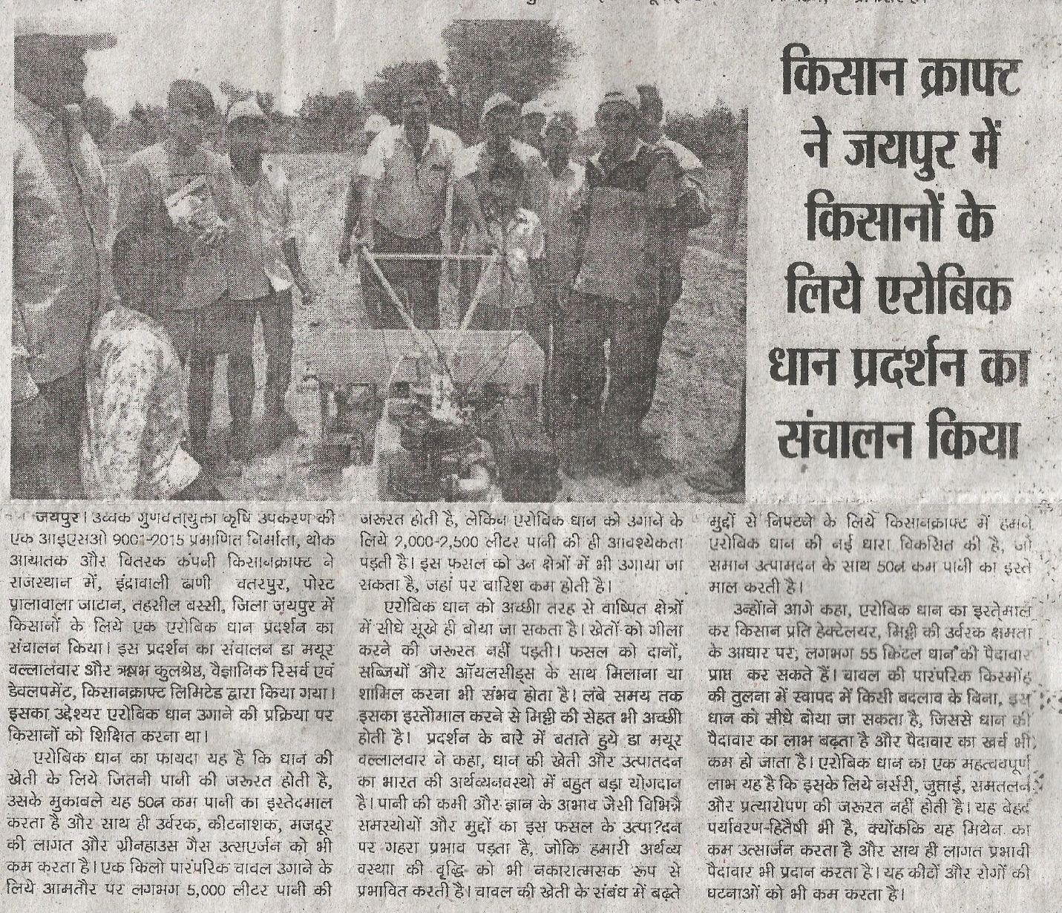

Publication | Evening Plus
Headline | Regional
Date | 03/07/2019

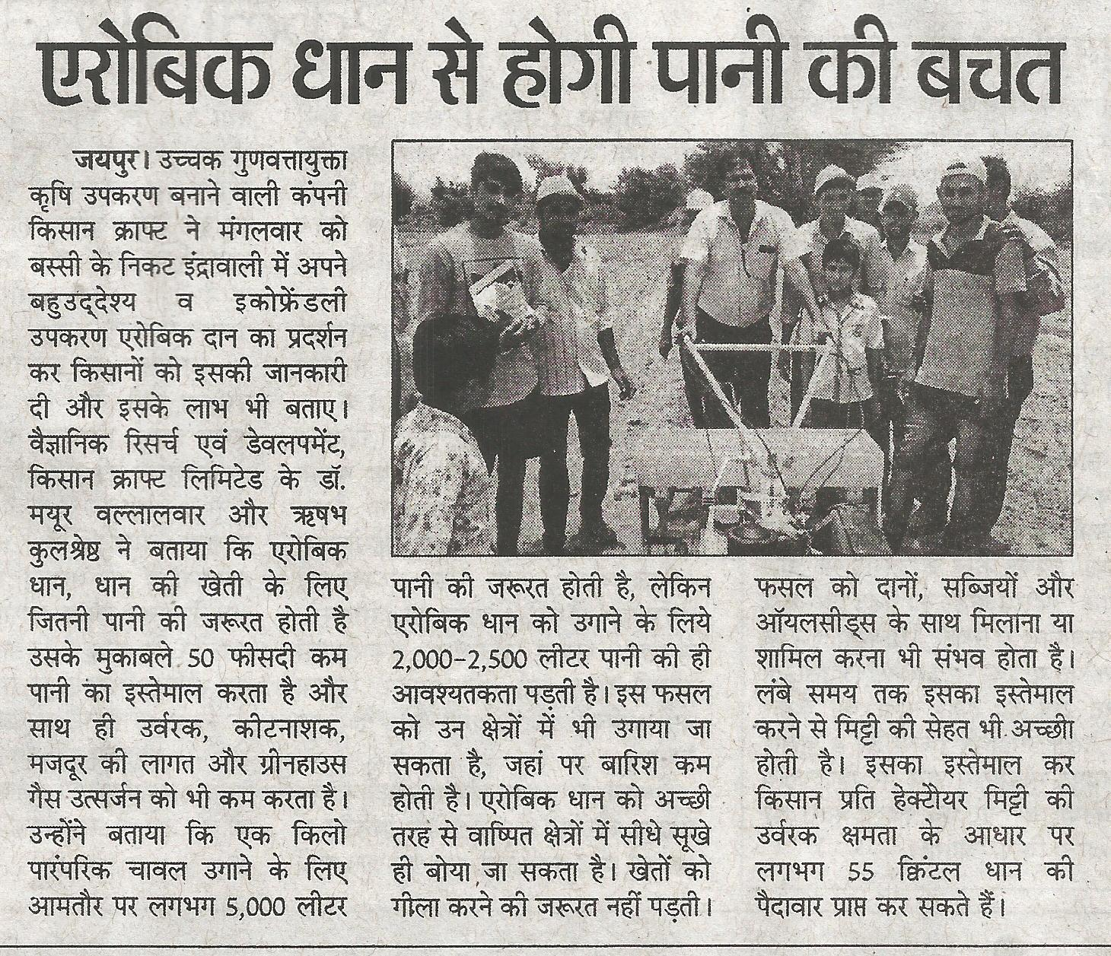

Publication | The Public Side
Headline | KisanKraft conducts Aerobic Rice demonstration for farmers in Jaipur District
Date | 03/07/2019

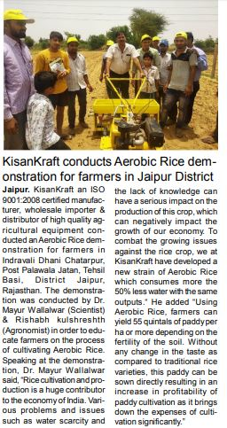

Publication | Adhikar
Headline | Regional
Date | 03/07/2019

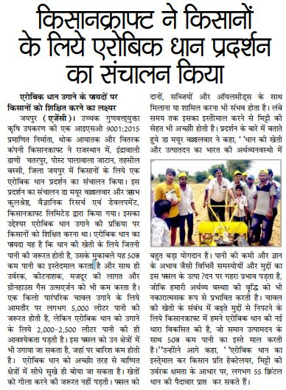

Aerobic rice Demonstration

Trichy

Coverage

TV Channel | Sun TV

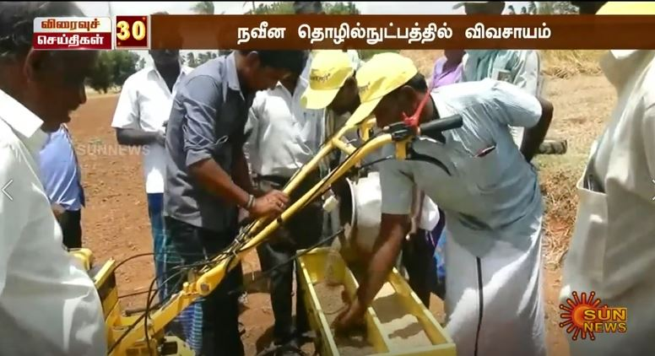

TV Channel | Polimer TV

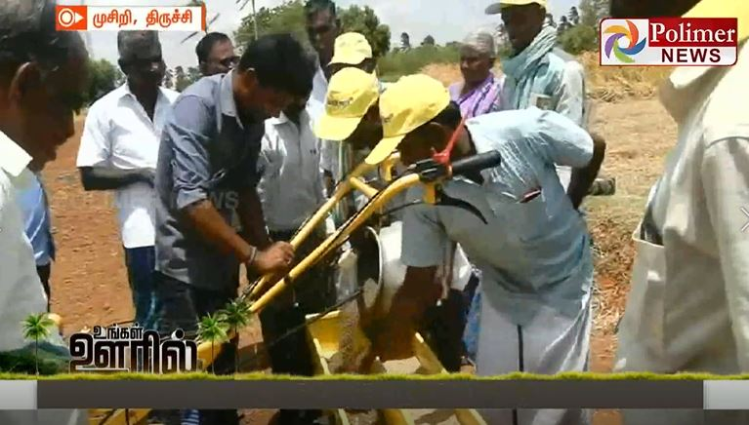

Email Interaction Coverage - Sakal (July 11,2019)

Coverage
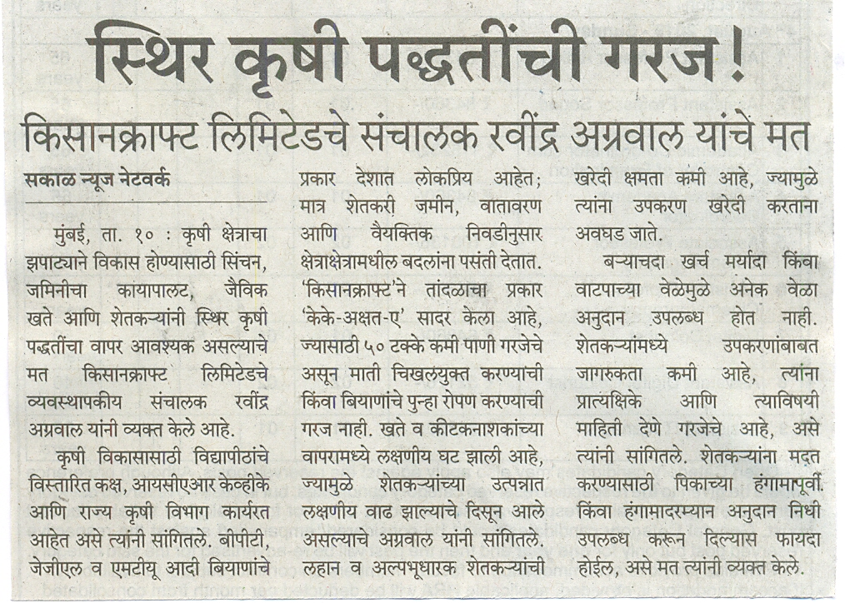

Pre Budget expectation – Authored Article
Coverage

Publication | Sify.com
Headline | With scope for massive change, the budget is perfect time to strike it for the farming sector
Link | http://www.sify.com/finance/with-scope-for-massive-change-the-budget-is-perfect-time-to-strike-it-for-the-farming-sector-news-business-thbqTIhacijhg.html
Date | 01/07/2019

Publication | Amrit India
Headline | Regional
Date | 03/07/2019

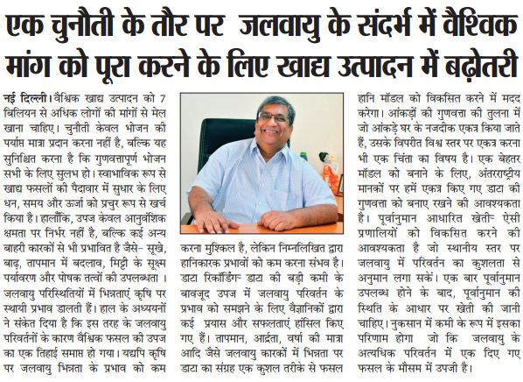

Pre budget quote

Coverage

Publication | Haryana Mail
Headline | Regional
Date | 03/07/2019
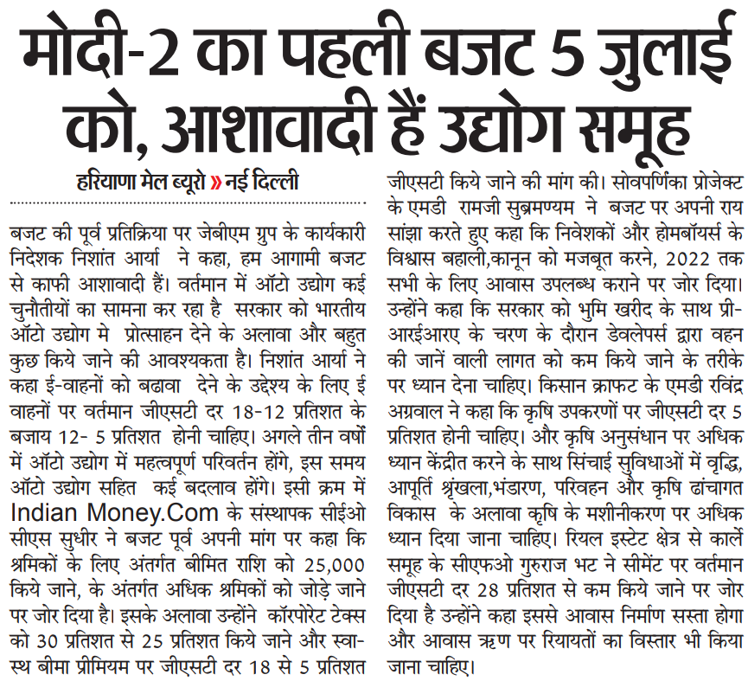

Publication | Gurgaon Today
Headline | Regional
Date | 03/07/2019

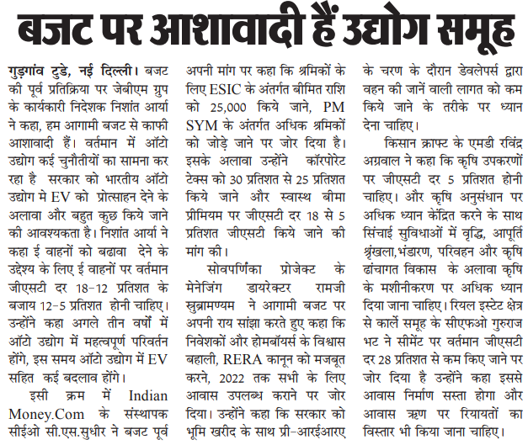

Publication | Virat Vaibhav
Headline | Regional
Date | 03/07/2019

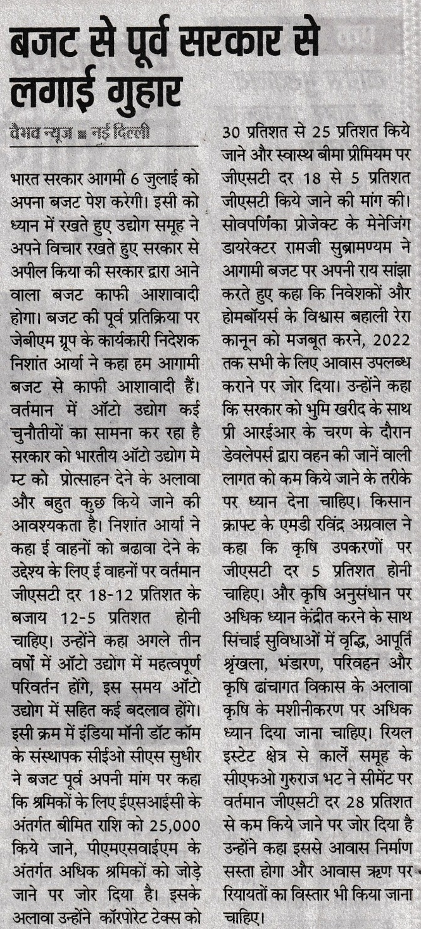

Publication | Amrit India
Headline | Regional
Date | 03/07/2019

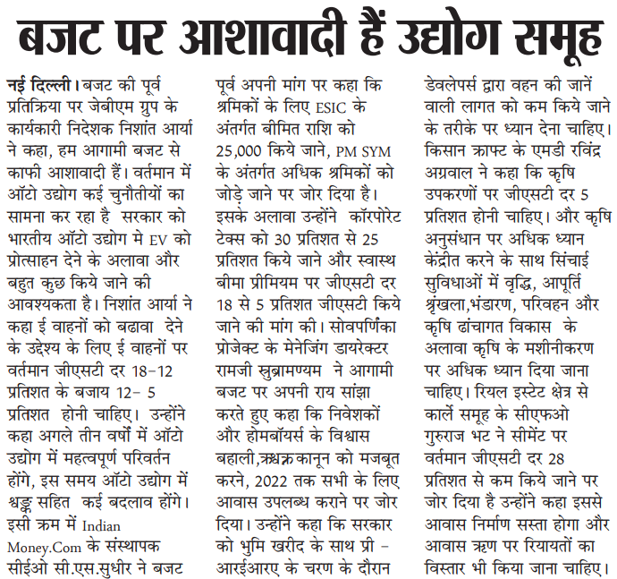

Publication | National Duniya
Headline | Regional
Date | 03/07/2019

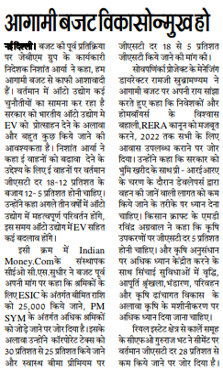

Publication | Firstpost
Headline | Union Budget 2019: From tax cuts to lowering of AFT pricing, Corporate India presents its wish list to Nirmala Sitharaman
Date | 03/07/2019
Link | https://www.firstpost.com/business/union-budget-2019-from-tax-cuts-to-lowering-of-aft-pricing-corporate-india-presents-its-wish-list-to-nirmala-sitharaman-6919631.html

Post budget quote

Coverage

Publication | Times Of India
Headline | Budget 2019 a mixed bag for farm industry: Experts
Date | 05/07/2019
Link | https://timesofindia.indiatimes.com/business/india-business/budget-2019-a-mixed-bag-for-farm-industry-experts/articleshow/70094637.cms

Publication | Business Standard
Headline | Budget 2019 a mixed bag for farm industry: Experts
Date | 05/07/2019
Link | https://www.business-standard.com/article/pti-stories/budget-2019-a-mixed-bag-for-farm-industry-experts-119070501242_1.html

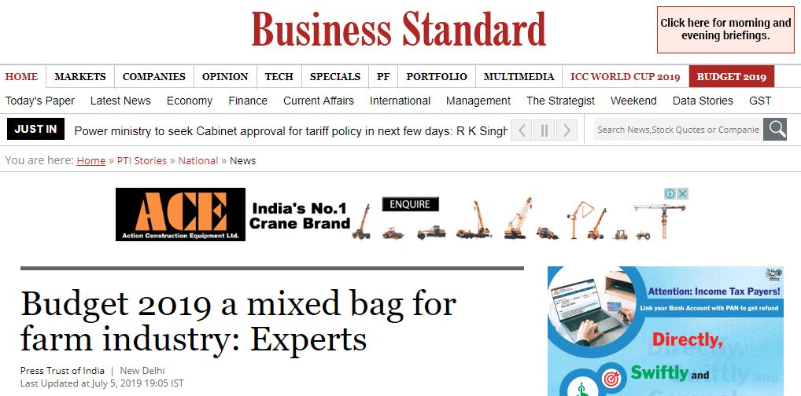

Publication | National Duniya
Headline | Regional
Date | 07/07/2019

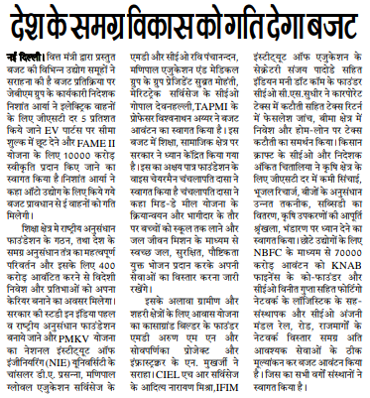

Publication | Veer Arjun
Headline | Regional
Date | 07/07/2019

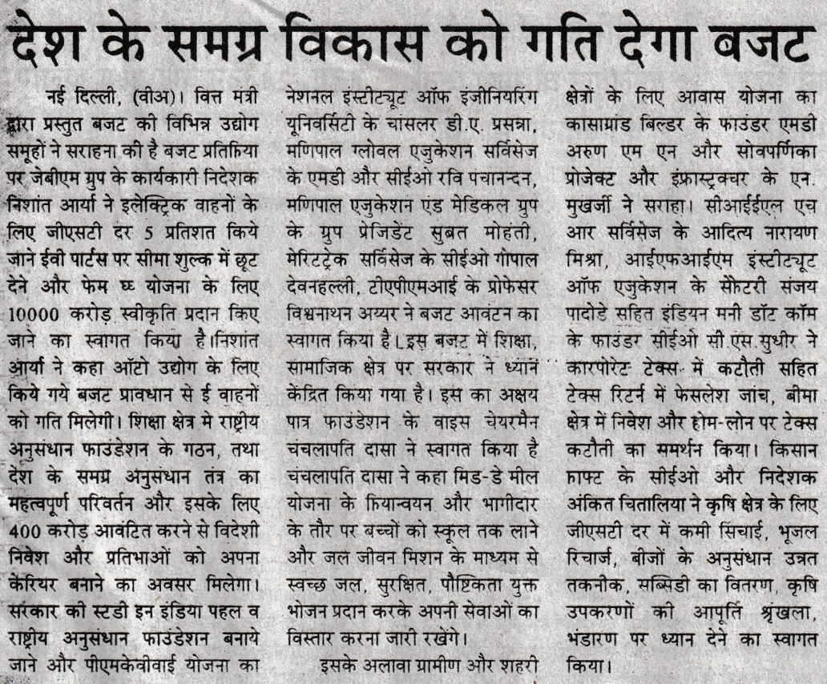

Publication | Gurgaon Today
Headline | Regional
Date | 07/07/2019

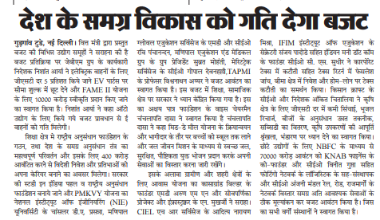

Publication | Firstpost
Headline | Industry Leaders Reaction on Budget 2019: Adi Godrej says Budget is not growth-oriented; stock market comes down considerably
Date | 06/07/2019
Link | https://www.firstpost.com/business/industry-leaders-reaction-on-budget-2019-adi-godrej-says-budget-is-not-growth-oriented-stock-market-comes-down-considerably-6940161.html

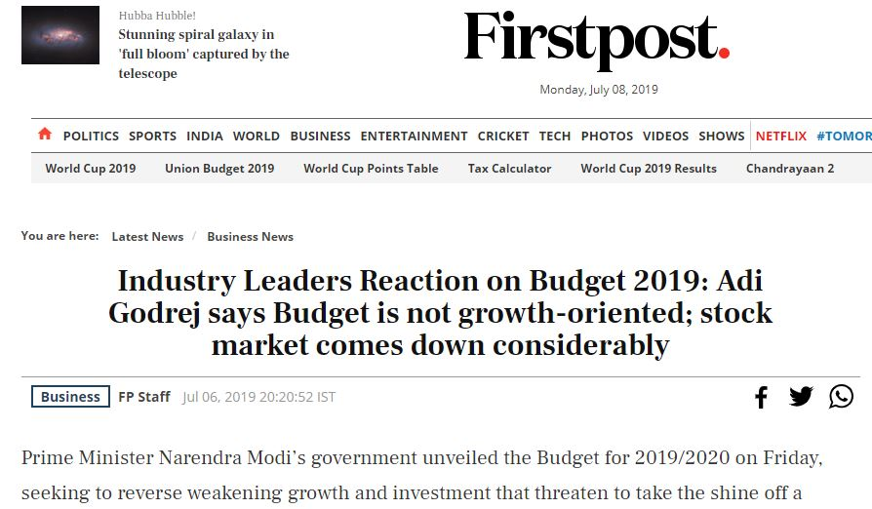

Publication | Navshakti
Headline | Regional
Date | 09/07/2019

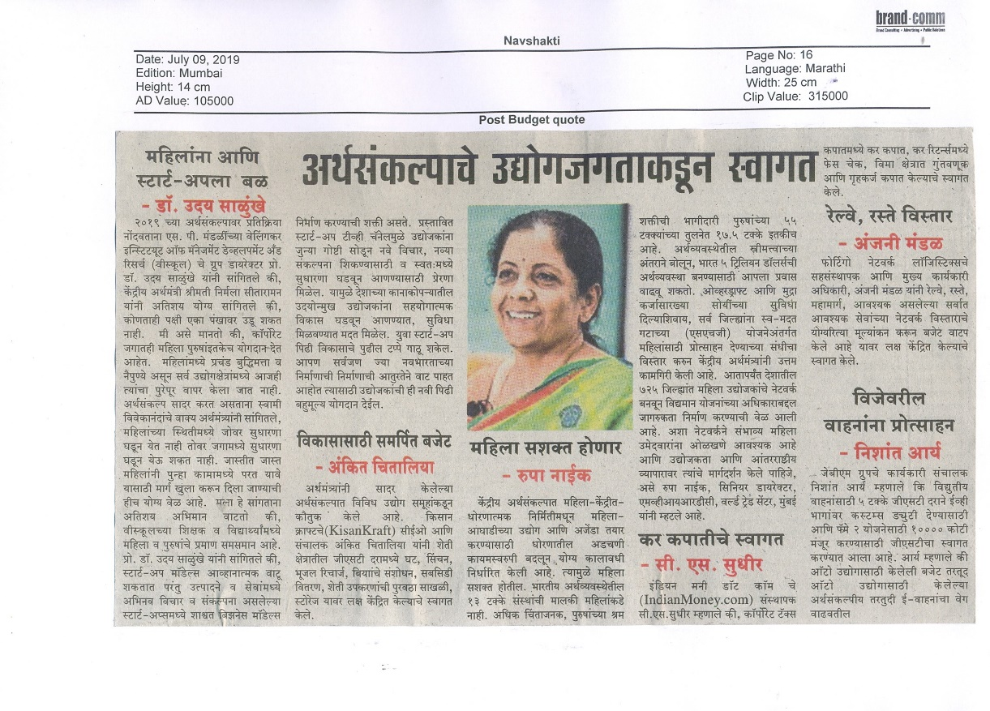

Publication | Amrit India
Headline | Regional
Date | 09/07/2019

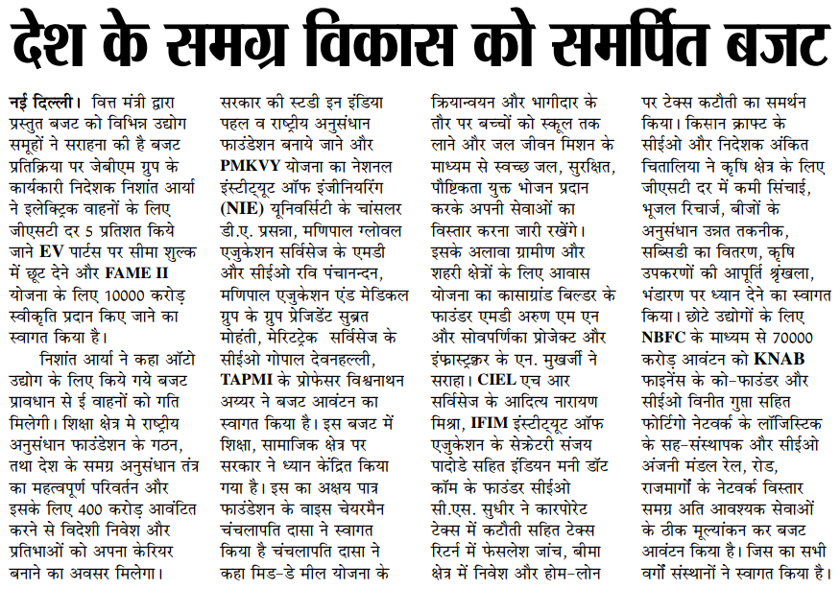

Publication | Haryana Mail
Headline | Regional
Date | 09/07/2019

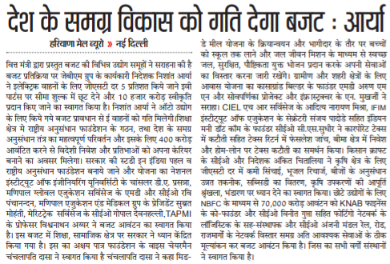

Farmer Education Drive In Nellore

Coverage

Publication | Andhra Jyothy
Headline | Regional
Date | 29/08/2019

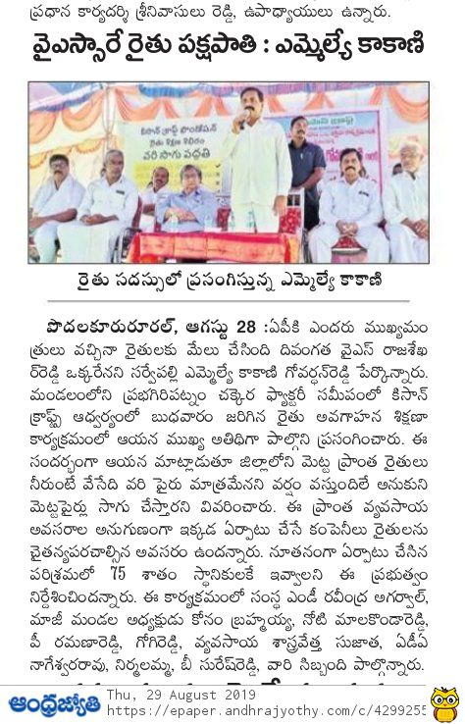

Publication | Prajashakthi
Headline | Regional
Date | 29/08/2019

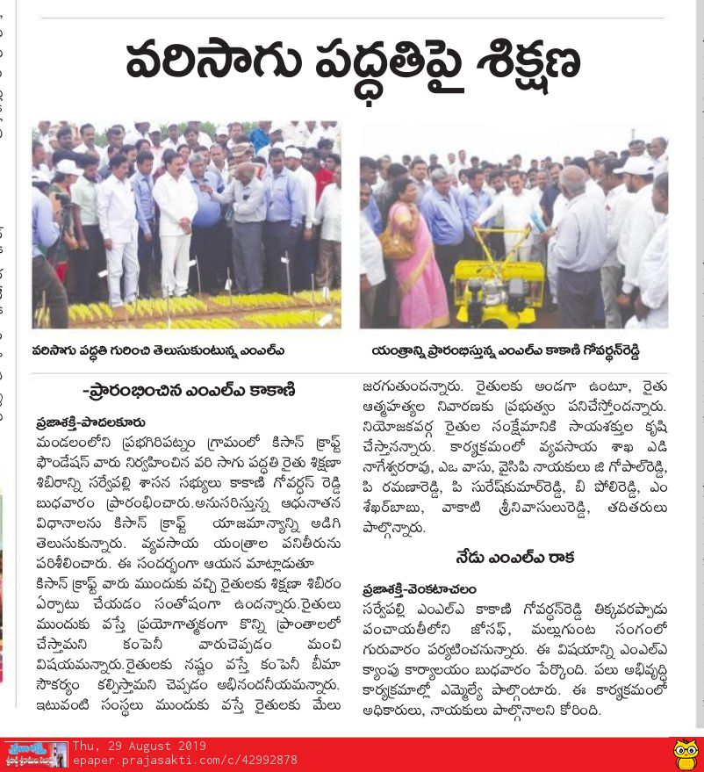

Publication | Sakshi
Headline | Regional
Date | 29/08/2019

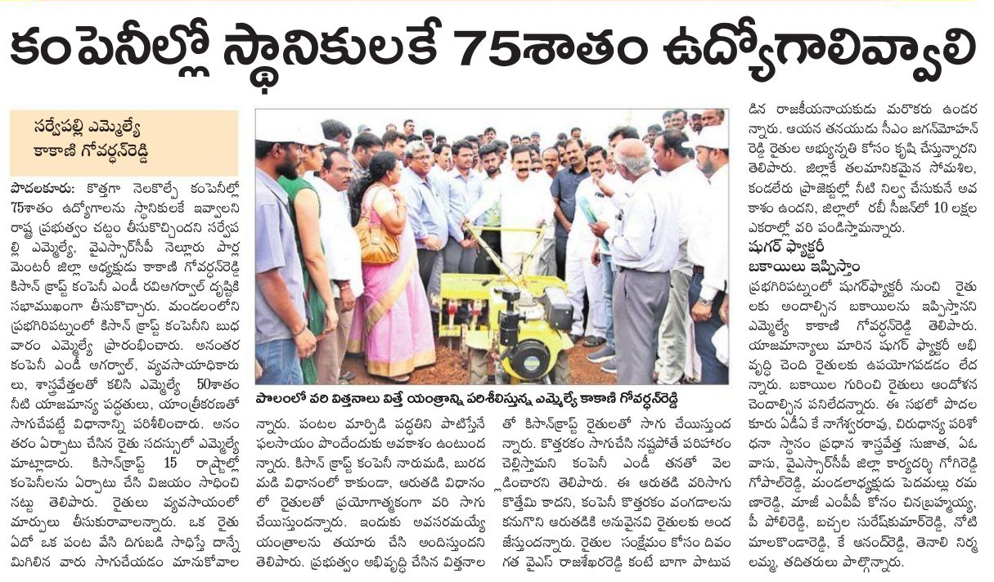

Publication | Andhra Prabha
Headline | Regional
Date | 29/08/2019

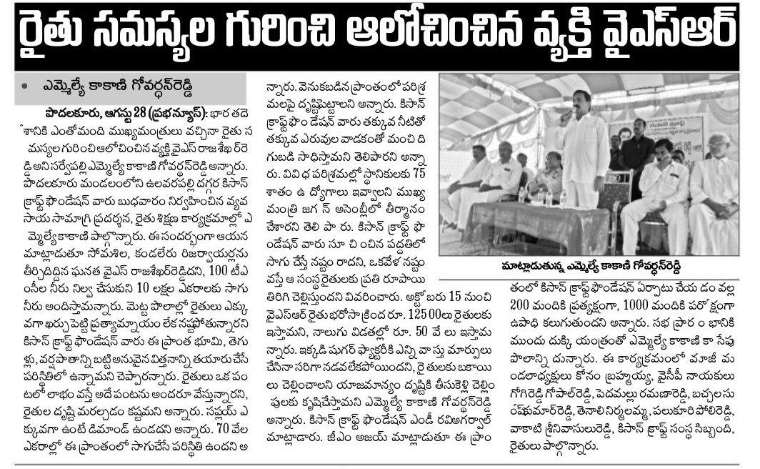

Publication | Eenadu
Headline | Regional
Date | 29/08/2019

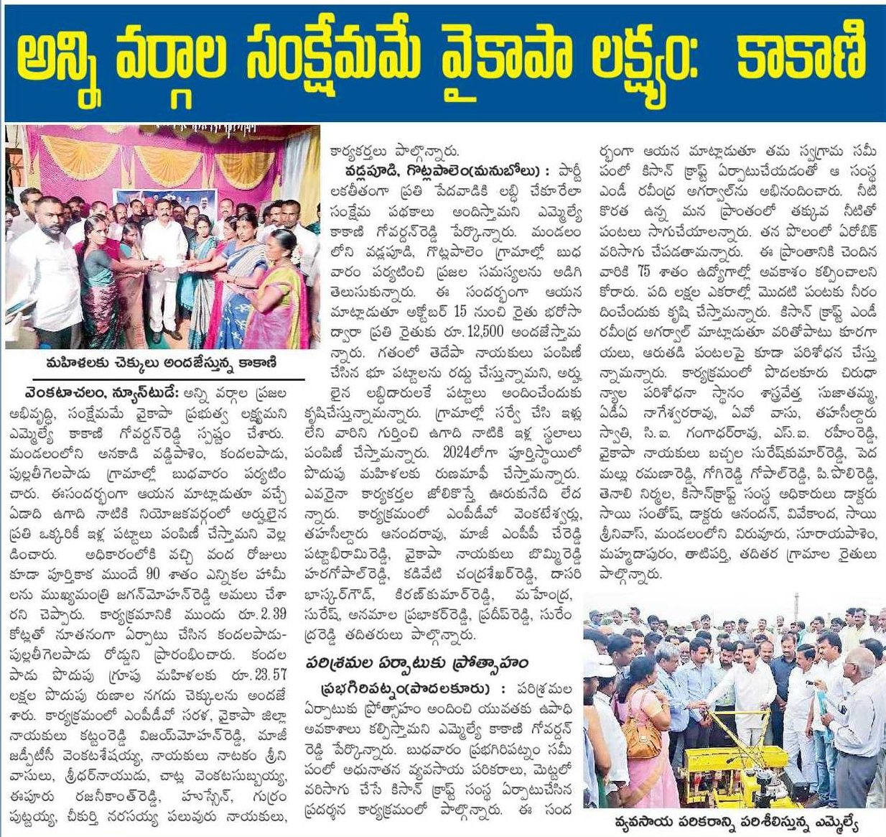

Publication | Vaartha
Headline | Regional
Date | 29/08/2019

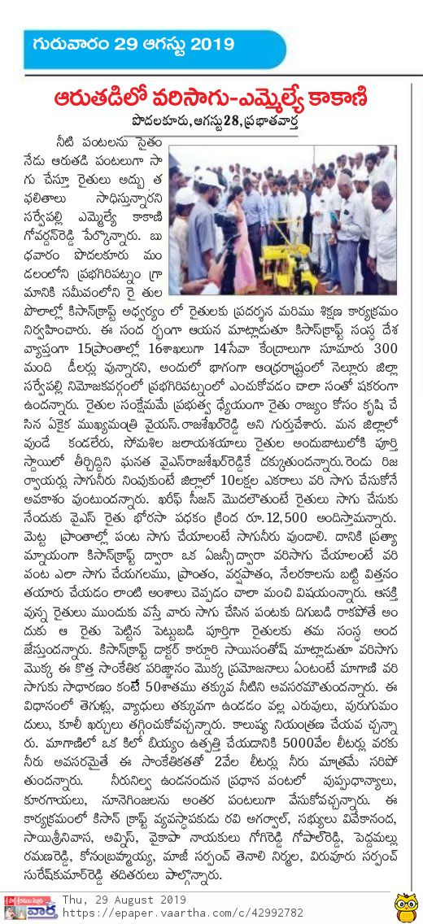

Aerobic rice demonstration Kanakapura
Coverage

Publication | Ramanagaram times
Headline | Regional
Date | 13/09/19

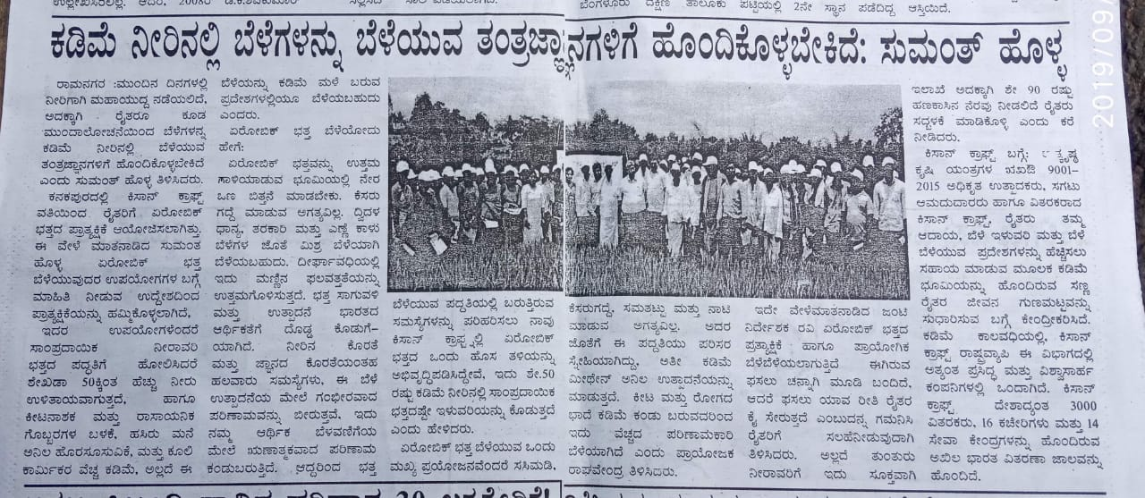

Publication | Udayavani
Headline | Regional
Date | 13/09/19

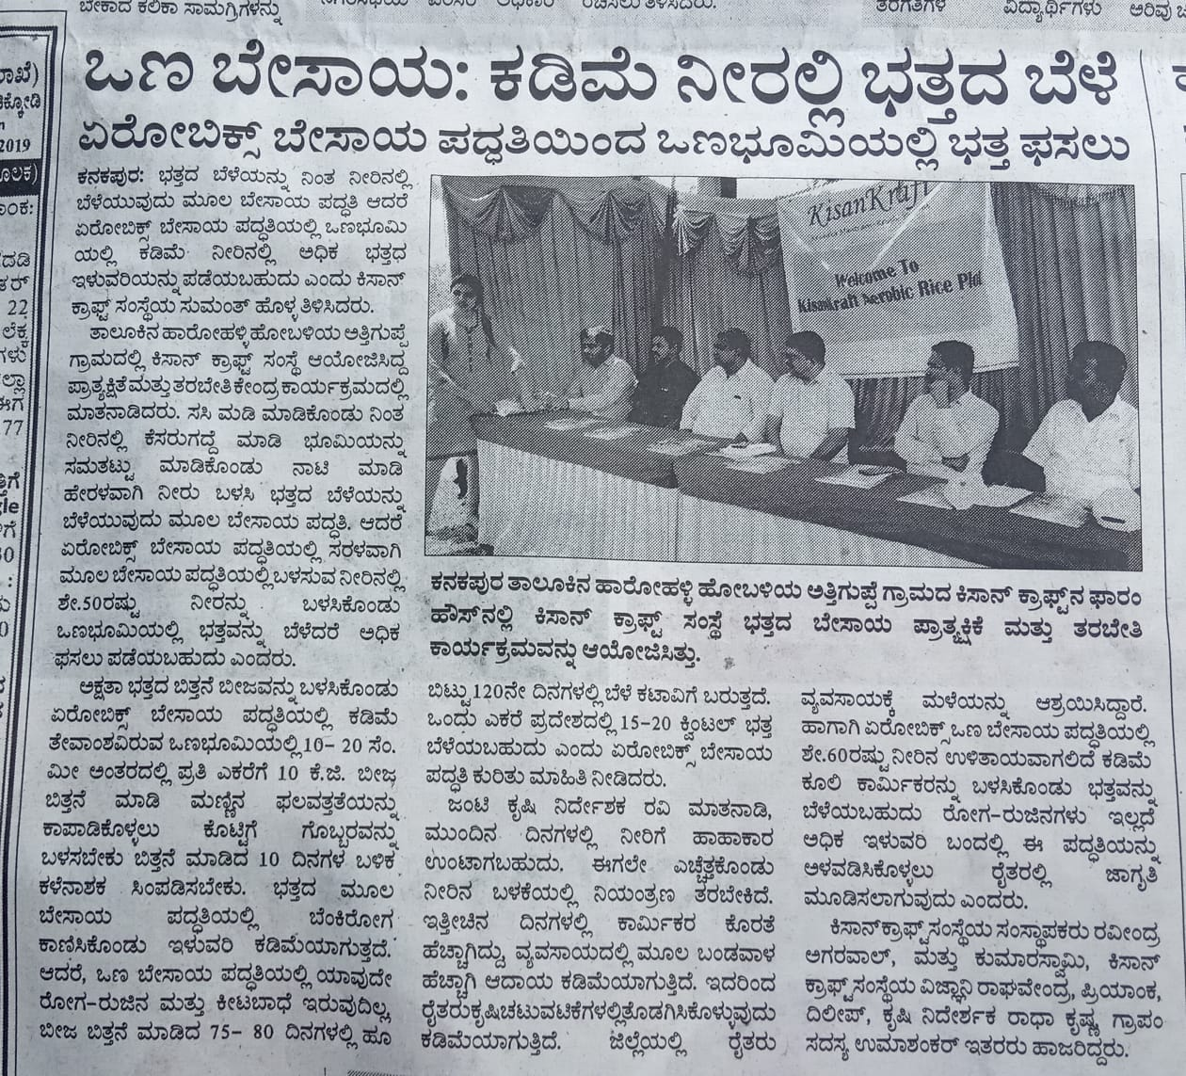

Publication | Hosadigantha
Headline | Regional
Date | 13/09/19

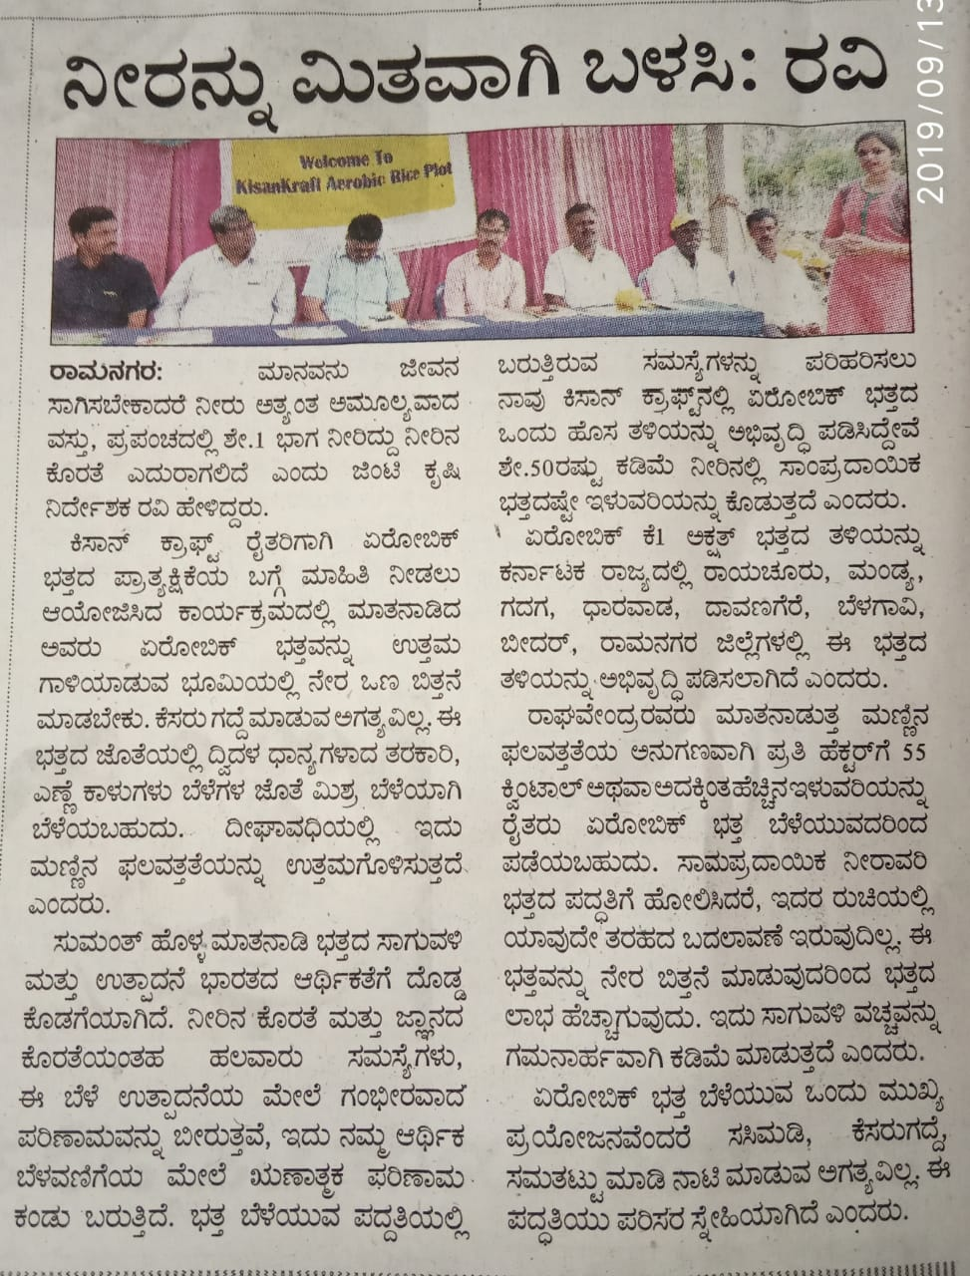

Publication | Indian Newz
Headline | KisanKraft conducts Aerobic Rice demonstration for farmers in Kanakapura
Date | 13/09/19
Link | https://indiannewz.wordpress.com/2019/09/13/kisankraft-conducts-aerobic-rice-demonstration-for-farmers-in-kanakapura/

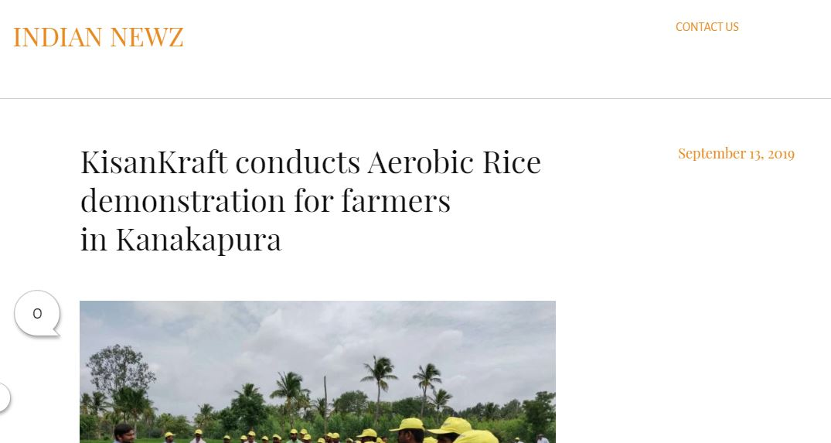

Publication | Prajavani
Headline | Regional
Date | 14/09/19
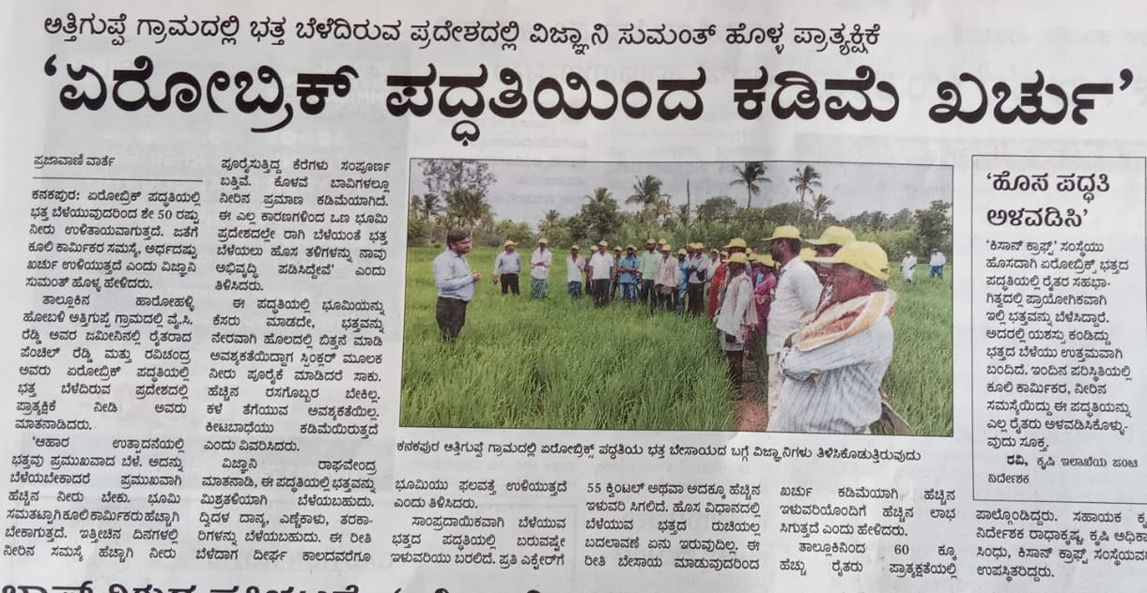

Publication | Masthama Vani
Headline | Regional
Date | 14/09/19

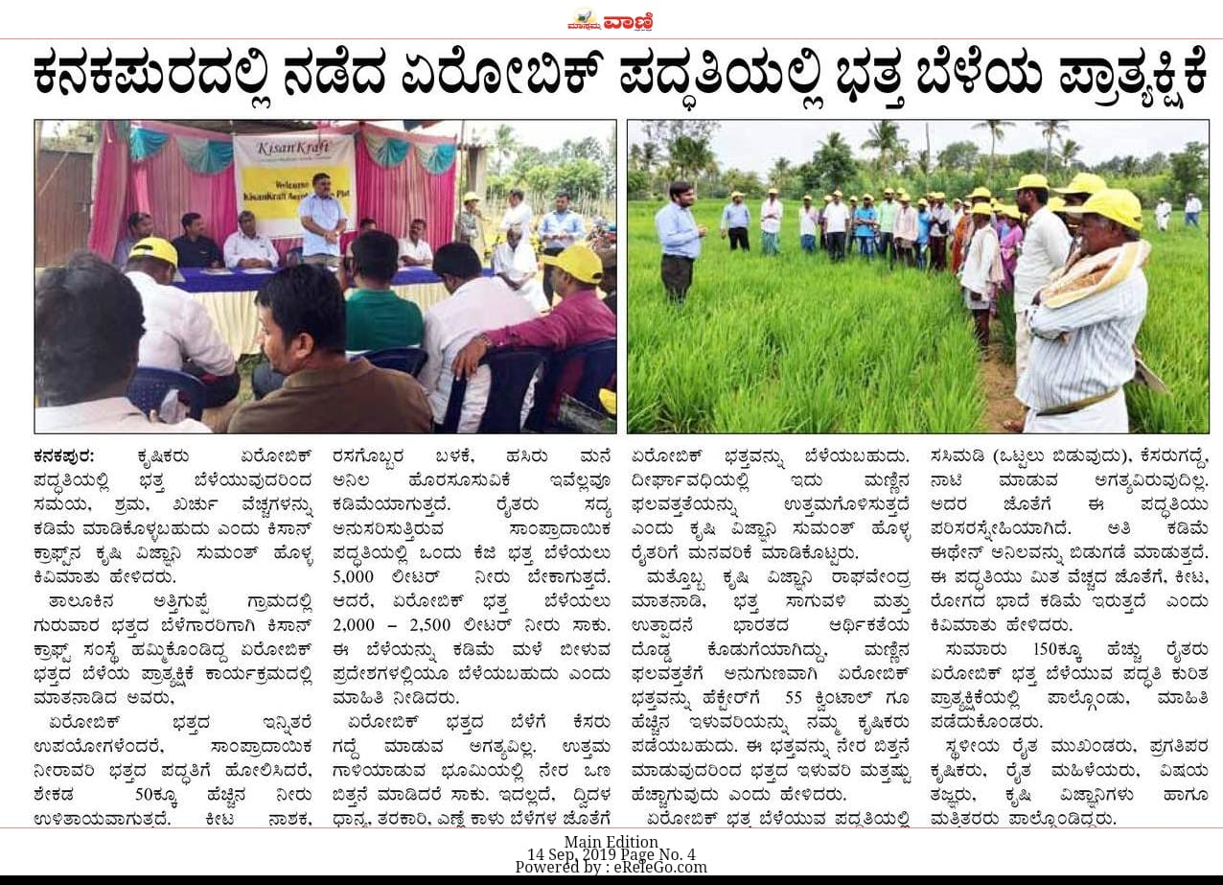

Publication | Jayavahini
Headline | Regional
Date | 14/09/19

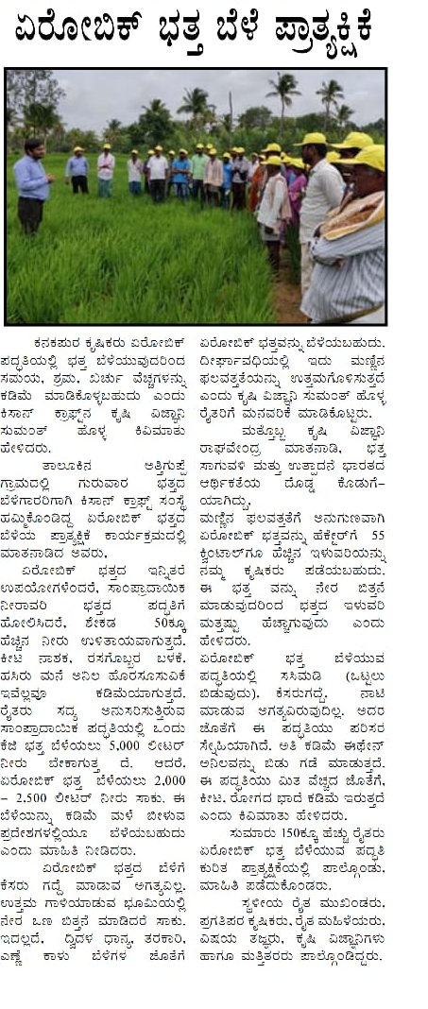

Publication | Ee Sanje
Headline | Regional
Date | 14/09/19
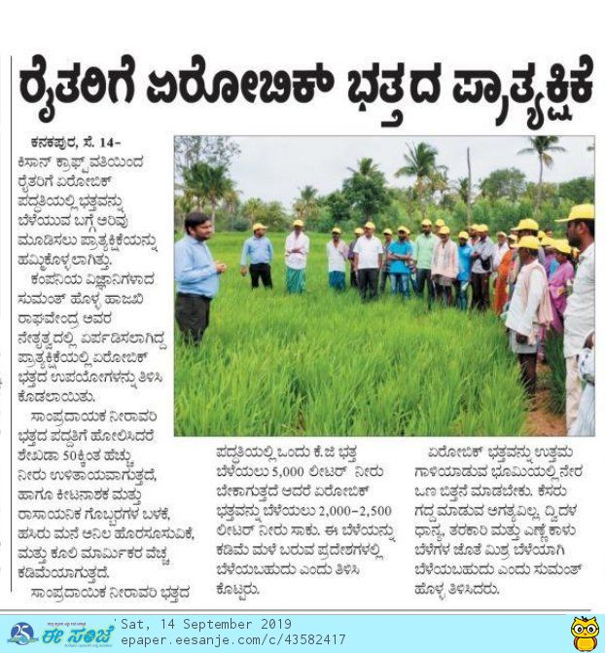

Publication | This Week India
Headline | KisanKraft conducts Aerobic Rice demonstration for farmers in Kanakapura
Date | 14/09/19
Link | https://thisweekindia.news/article/kisankraft-conducts-aerobic-rice-demonstration-for-farmers-in-kanakapura/21172

Publication | GP Media
Headline | KisanKraft conducts Aerobic Rice demonstration for farmers in Kanakapura
Date | 13/09/19
Link | https://gpmediaweb.wordpress.com/2019/09/13/kisankraft-conducts-aerobic-rice-demonstration-for-farmers-in-kanakapura/

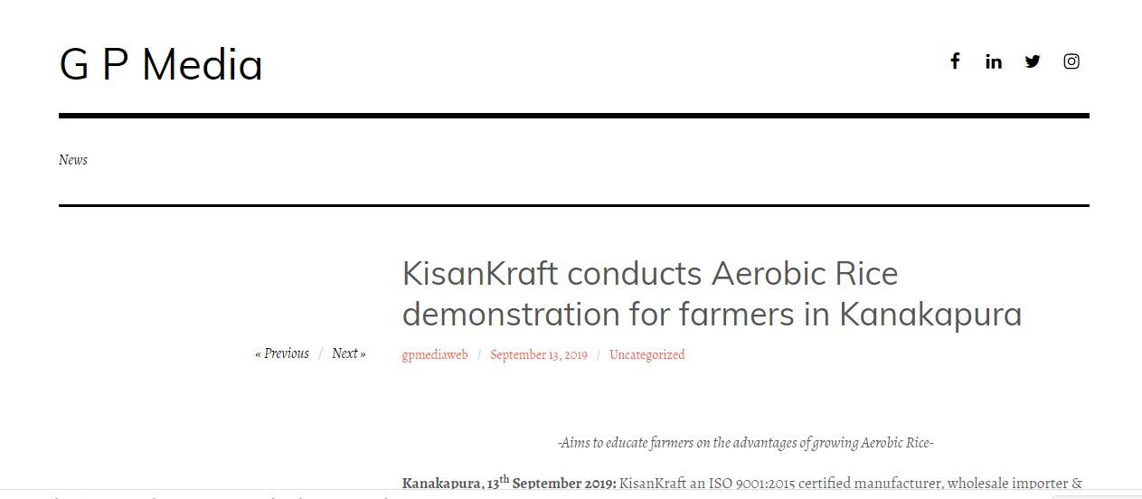

Publication | Kannada Prabha
Headline | Regional
Date | 17/09/19

