QUATERLY REPORT

April - June

2019

Presented by

Month |  | Activity
April | - Farmer Education drive - MP  - Farmer Education drive - AP
May | - Interview with Sakal for a story on Making agriculture a profession and not a way of life  - Authored article on 'Pacing food production with global demand'  - Interaction with the Dainik Bhaskar on "Mechanization of farmers is the need of the hour"
June | - Sakal Q&A Interaction for a story on ‘Making agriculture a profession and not a way of life’  - Aerobic Rice Demonstration in Jagtial  - Authored article on budget expectations from the agri sector  - Authored article on 'Pacing food production with global demand'  - Interaction with the Dainik Bhaskar on "Mechanization of farmers is the need of the hour"  - Profiling opportunity with Malayalam media

Activity Highlights

- Farmer education drive - MP
Status: Coverge received and shared

- Farmer education drive - AP
Status: Coverge received and shared

- Authored article on 'Pacing food production with global demand'
Status: Coverage received and shared
- Interaction with the Dainik Bhaskar on "Mechanization of farmers is the need of the hour"
Status: Coverage received and shared
- Sakal Q&A Interaction for a story on ‘Making agriculture a profession and not a way of life’
Status: Responses shared, awaiting coverage
- Aerobic Rice Demonstration in Jagtial
Status: Coverage received and shared
- Authored article on budget expectations from the agri sector
Status: Coverage received and shared
- Profiling opportunity with Malayalam media
Status: Pitch shared with media, awaiting response

MP Rewa Demonstration

Coverage

Publication | Navbharat

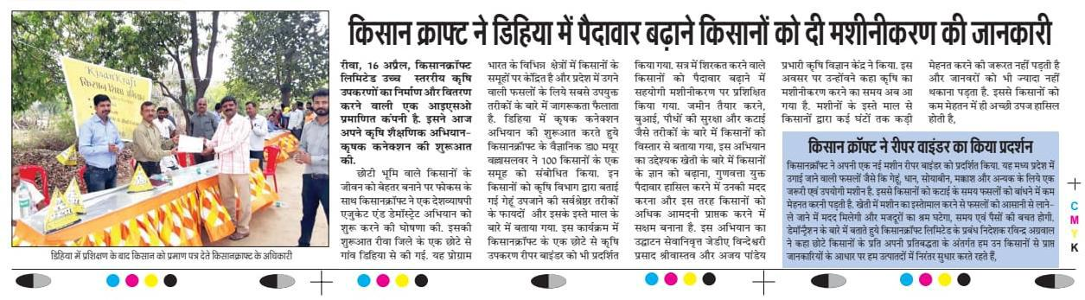

Publication | Star Samachar

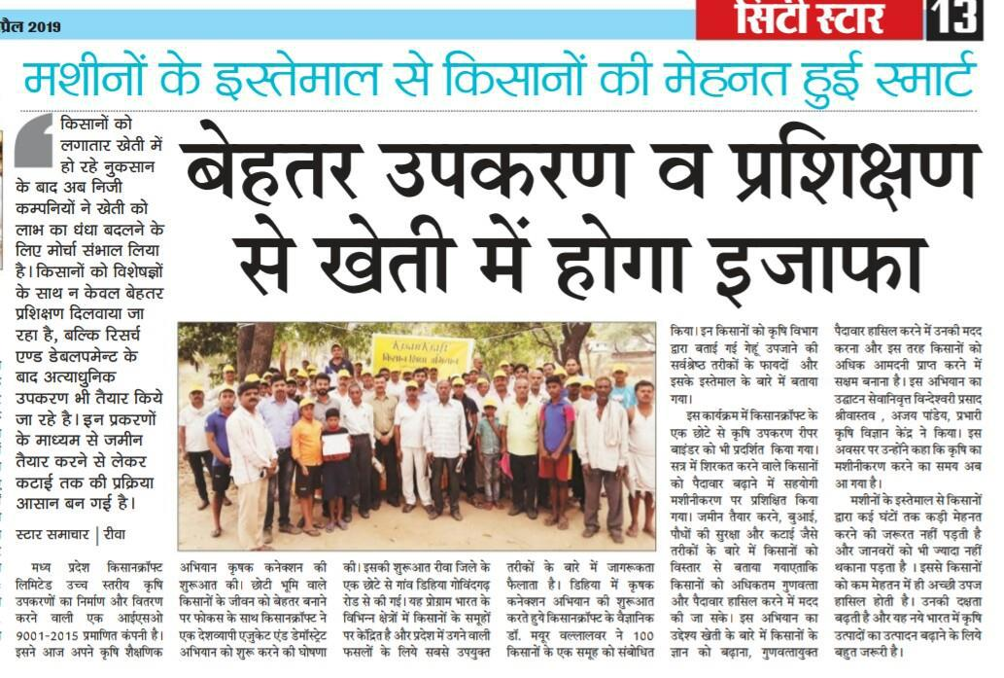

Publication | Dainik Bhaskar
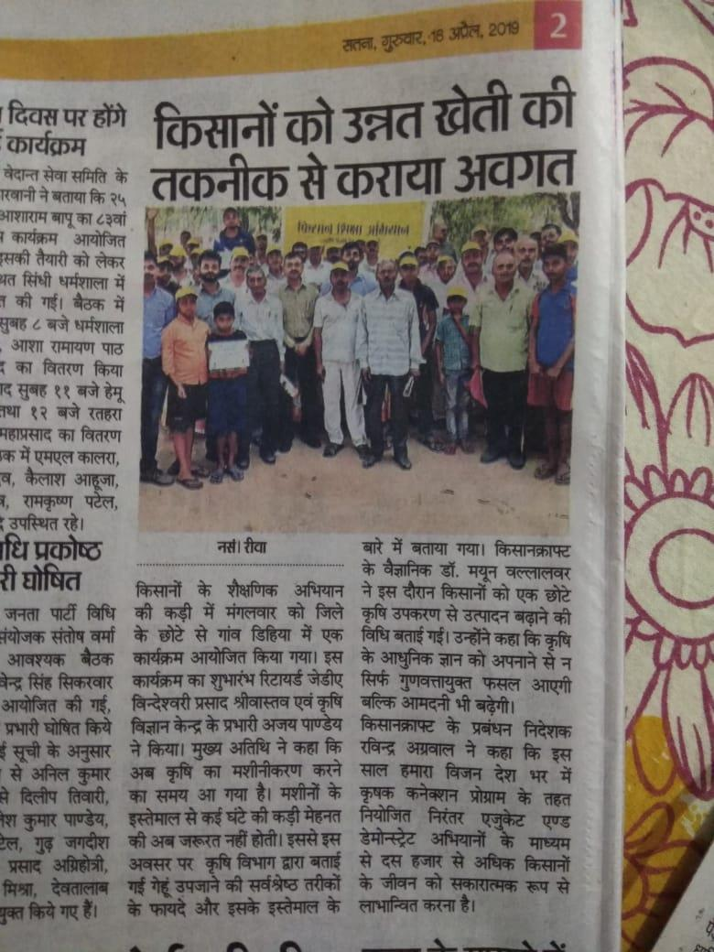

Publication | Dainik Jagaran
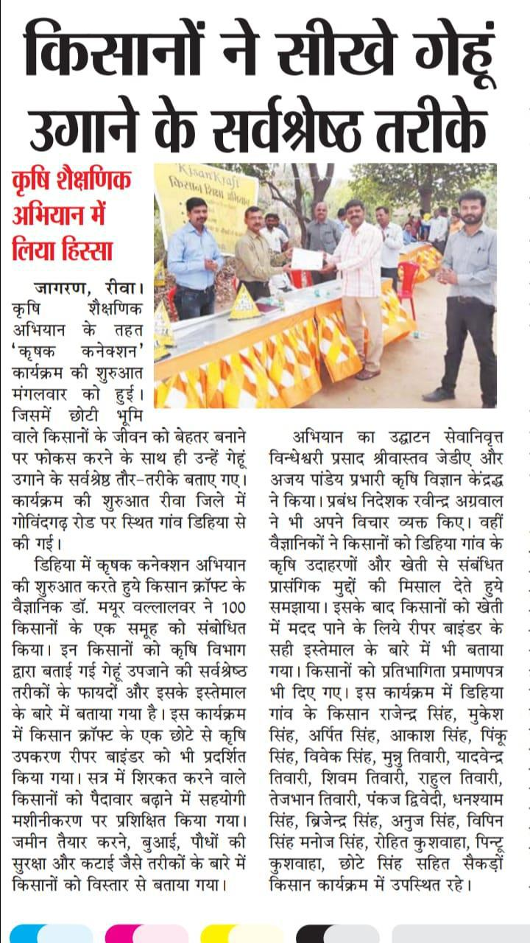

MP Ananthapalli Demonstration

Coverage

Publication Sakshi
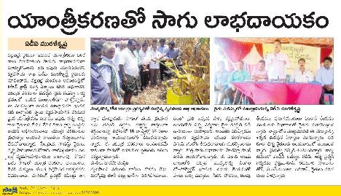

Publication | Andhra Jyothi
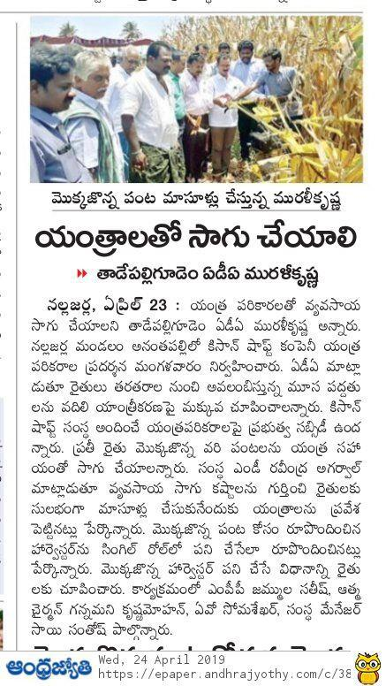

Publication Prajashakthi
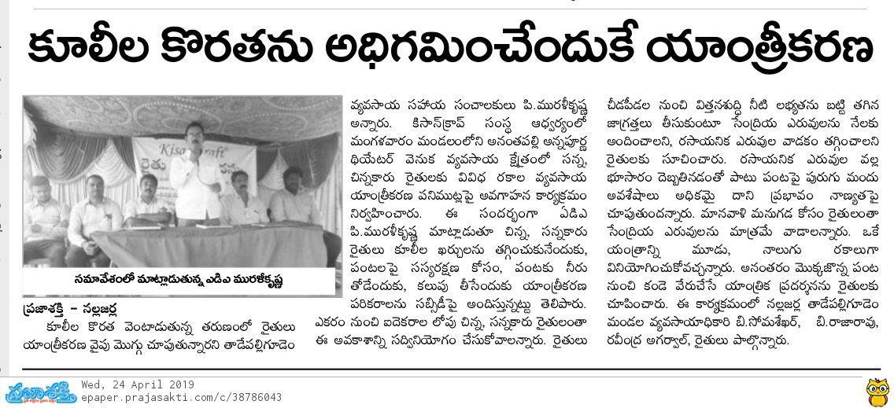

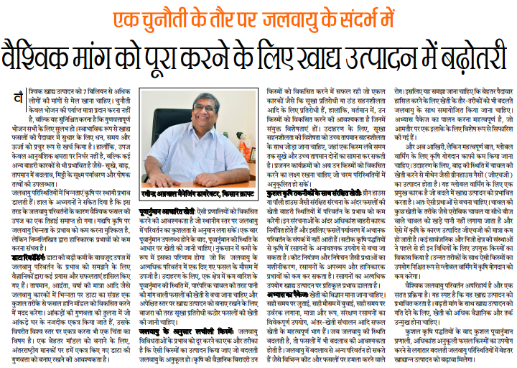
Authored article on 'Pacing food production with global demand'
Publication | National Duniya
Date | 18-06-19
Headline | Regional

Publication | Virat Vaibhav
Date | 18-06-19
Headline | Regional

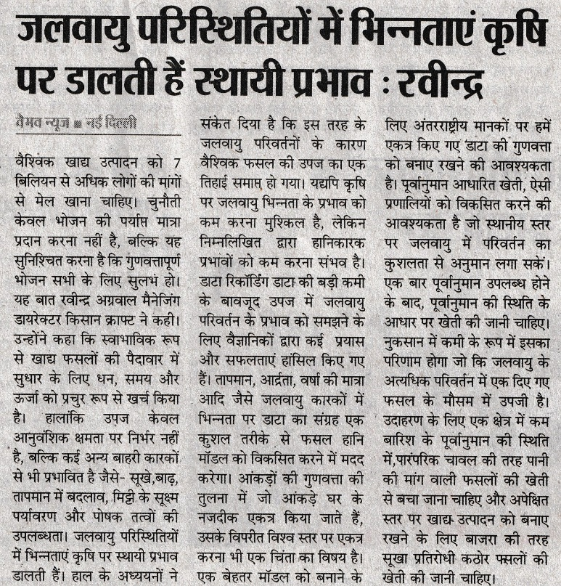

Publication | Haryana Mail
Date | 19-06-19
Headline | Regional

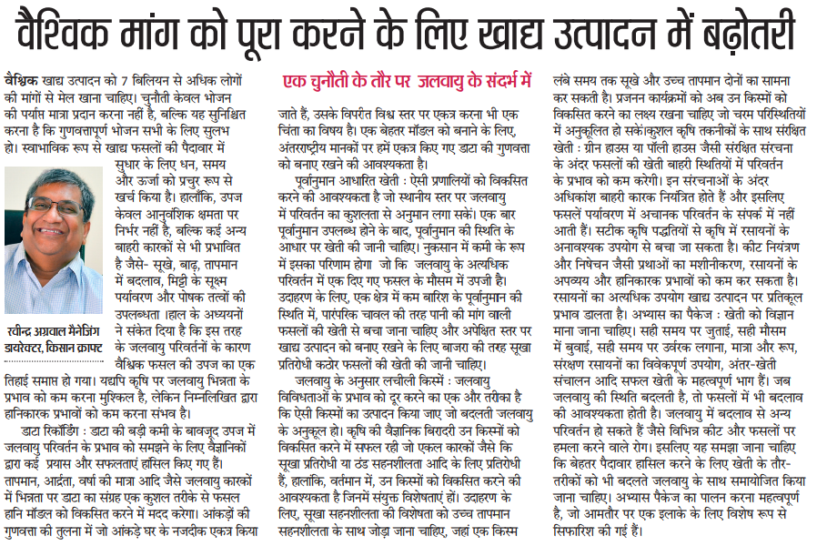

Aerobic Rice Demonstration:
Jagtial
Publication | Andhra Jyothi
Headline | Regional
Date | 27-06-19

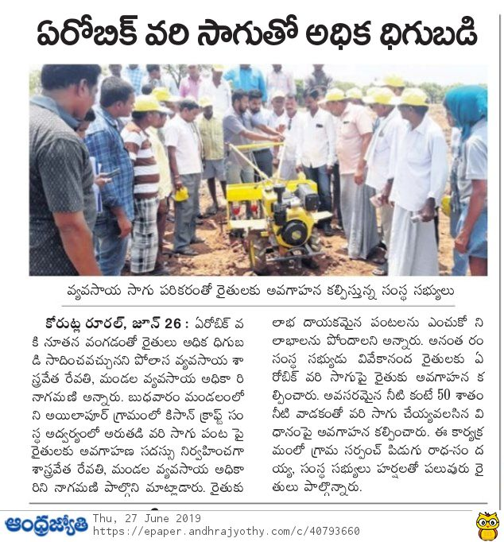

Publication | Eenadu News
Headline | Aerobic Rice
Date | 27-06-19

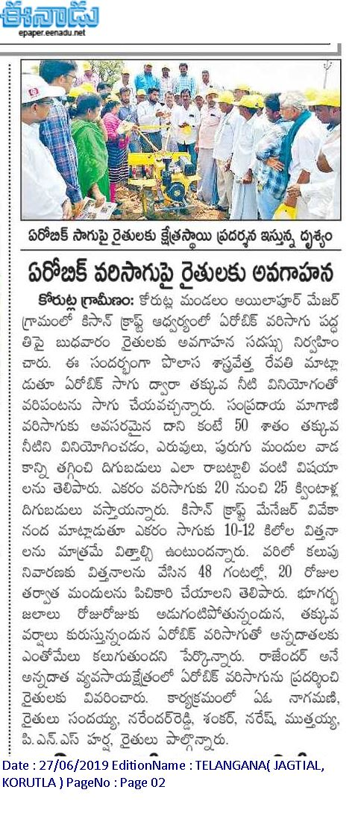

Publication | Namaste Telangana
Headline | Aerobic Rice
Date | 27-06-19

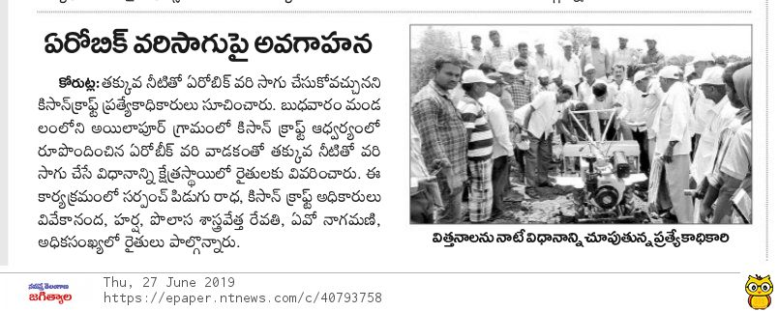

‘Mechanization of farmers is the need of the hour’
Publication | Dainik Bhaskar
Headline | Regional
Date | 15-06-19

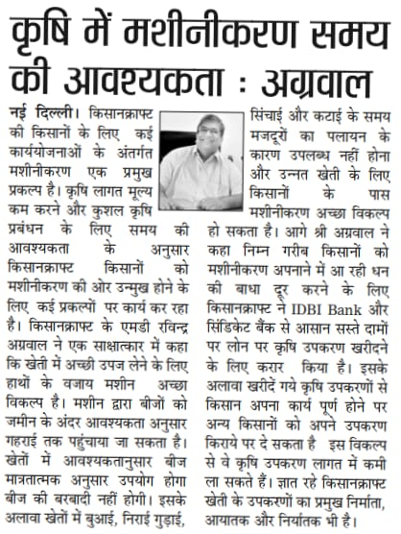

Authored article on budget expectations from the agri sector

Publication | Sify.com
Date | 01-07-2019
Link | http://www.sify.com/finance/with-scope-for-massive-change-the-budget-is-perfect-time-to-strike-it-for-the-farming-sector-news-business-thbqTIhacijhg.html

